EFFECT OF NANDROLONE DECANOATE ON VOICE AND REPRODUCTIVE TISSUES IN WISTAR RAT: HISTOPATHOLOGICAL AND MORPHOMETRIC ASSESSMENT
Osahon Roli Itohan^{1*}, Ebeye Oladunni Abimbola², Ehebha Santos Ehizokhale¹,and Dare, NerveyWillie³.
¹Department of Anatomy, Faculty of Basic Medical Sciences, Edo University Iyamho, Edo State, P.M.B 04
²Department of Human Anatomy and Cell Biology, Faculty of Basic Medical Sciences, Delta State University, Delta State.
³Department of Anatomy, Faculty of Basic Medical Sciences, Niger Delta University Wilberforce Highland.
*Corresponding author email: itohanroli61@gmail.com

ABSTRACT
Background:Nandrolone Decanoate (ND) artificial testosterone in the steroid forum is of significant effect essential in clinical settings for the treatment of chronic diseases. Its mechanism of action is apparent by binding to receptor complexes such as hormones producing anabolic and androgenic effects. Objectives:To research the effects of ND on the reproductive system of Adult Wistar rats as well as on the voice of female Wistar rats exposed to the physical and non-physical activity. Methods: In this experimental study, 12 models (6 males, 6 females) received 5mg/kg BW of DecaDurabolin base on their weight indicating a normal dose once a week for four weeks. The Active models were subjected to aerobic swimming as the physical activity. Results: Female voice sounds decrease progressively from a sharp whistle-like sound to blunt and finally dull sounds. Also, the histological analysis revealed that the inactive males were with reduced spermatogenic activities, hyperplasia of the interstitial cell of Leydig with congested blood vessels in the testis while the inactive female analysis revealed foci of congestion around the cortical and medullary regions of the ovary. The histological analysis of the active males revealed reduced germ cells in the seminiferous tubules, sloughing of the germinal epithelium and interstitial edema of the testis, while the ovary revealed well-defined blood vessels within the medulla and medullary congestion. Conclusion: Administrationof Nandrolone Decanoate was associated with deleterious effects on active and inactive models on the testis, ovaries,and, voice.

Keywords: Nandrolone Decanoate, Testis, Ovary, Testosterone, Wistar rat.
INTRODUCTION
It is important to bring to mind that Nandrolone Decanoate (ND) an Anabolic-androgenic Steroid which contains a high class of synthetic androgens has the ability to mimic male sex hormones such as testosterone and dihydrotestosterone(Tanehkar et al.,2013). Possession of both natural and synthetic androgen qualities has proven that testosterone and its derivatives are composed of ND gives it a special function of cellular tissue build-up (anabolism) associated with increased protein synthesis within a cell such as muscular tissue(Bhasin,1996; Forbes et al.,2016). In action, AAS act via androgen receptor, producing anabolic and androgenic effects on target cells (Ebeye et al., 2016). Clinically, ND is used as a regimen in the treatment of numerous pathological conditions such as anemia, angioedema, breast cancer, and endometriosis among others (Belardin et al., 2014). Despite its therapeutic use, yet it has been abused over the years among athletes, especially body-builders, military personnel to improve their physical performance, muscular growth, and aggressive character(Ebeye, 2016; Bird et al., 2016). This had drawn the attention of health researchers to investigate the effects of misuse and abuse of AAS on various organs, beyond an iota of doubt misuse of AAS had resulted in fatalities or mild effects, revealing the high risk of fatality of the heart, myocardial infarction, altered serum lipoproteins, and cardiac hypertrophy (Frati, 2015; Tamara, et al., 2017) depending on the period of use.
Recent studies suggested that subcutaneous administration of Nandrolone Decanoate resulted in an increased count of atretic follicles and reduced ovarian oocytes on their experimental model (Camargo ICC, et al., 2014). Long- and short-term administration of Nandrolone Decanoate revealed a significant decrease in the number of Leydig cells while the reduction of testosterone was peculiar to long term administration of Nandrolone Decanoate (Rahil et al., 2015). Intramuscular administration of Nandrolone Decanoate has led to improved body weight by the presence of relatively less primary follicles during treatment and withdrawal periods of 30 and 60 days respectively (Saddick et al., 2018). Persistent distressdecrease in ovarian weight, reduction of corpora lutea, enthrall, growing follicles and estrous cycle mutations which are associated with 30-day administration of Nandrolone Decanoate without complete recovery after 60-days of withdrawal observation (Simão et al., 2015).
It’s imperative to know the significant importance of physical exercise on the body system and organs, voluntary exercise has the ability to ameliorate body systems. To investigate this, the study aims at observing the significant effect of physical exercise with the administration of ND. However, a concise literature search shows that the effect of the normal dose of ND on the reproductive system (testis and ovary) and on the voice of female Wistar rats had received less attention, hence this current research was set to investigate any significant effect of the normal dose of Nandrolone Decanoate on the reproductive system (testis and ovary) and on the voice of female Wistar rats.

MATERIALS AND METHODS
Animals
The experimental study used 24 adult Wistar rats comprising of 12 male and female, (250 ±10) kg in body weight as experimental animals. The Committee on Animal Ethics, Department of Anatomy, Delta State University,Abraka, approved the feeding trial as well as an experimental protocol. All of the experimental methodologies were in line in accordance with the directive from the National Institutes of Health Guide for the Care and Use of Laboratory Animals.
Tissue Preparation and Processing
At the end four weeks regimen of Deca-Durabolin, the rats were sacrificed under anesthesia using chloroform as the sedative. The testis and ovaries were excised, rinsed under flowing water to get rid of blood stains and for macroscopic examination before being fixed at 10% formal saline solution for 72 hours. The tissues were trimmed to 4mm sizes, placed in tissue cassettes and processed with an automated tissue processor using different concentrations of dehydrating reagents. To acquire mechanical support, the tissues were placed in wax baths at the end of the dehydration process and sectioned with a microtome. The sectioned tissues were picked and floated on a water bath which was picked up by a slide, labeled, dried and stained using Haematoxylin and Eosin staining techniques as described by (Avwioro, 2014).

RESULTS

Experimental design
The models were randomly picked and distributed into 6 experimental groups, each group containing 4-30 weeks old adult male and female Wistar rats: the control group, active and inactive groups. These models were separately housed in cages and experienced 12-hours light and dark cycle, fed with food and distilled water ad libitum. Animals in the active group were subjected to physical activity of aerobic exercise were the experimental animals were placed in a large body of water and timed to assess the swimming ability and were taken out when they experience drowning, which was proceeded by complete immersion of the animals in the water and inability to swim out, while the inactive groups were not subjected to any form of physical activity as shown in Table 1 below.

Table 1: Experimental Design
Group | Group Title | Administration | Physical activity
A | Control | None | None
B | Inactive | ND | None
C | Active | ND | Aerobic exercise

ND-treated rats received an intraperitoneal injection of Deca-Durabolin obtained from a pharmaceutical store as an ampul solution having 50mg of androgen. The administration of ND was based on the weight of the models. Each model, excluding the control group, received 5mg/kg body weight of Deca-Durabolin once a week for four weeks.

Based on this research, it was discovered that the female models experienced toughening of voice as their whistle-like sharp sound produced at the beginning of the experiment became dull at the end of the experiment. The progressive changes in their voices are seen in Table 2 below.

Table 2: Shows the Progressive Changes in the Voice of Female Wistar Rats
Weeks of administration | Group A  Control | Group B  Inactive | Group C  Active
Week 1 | Sharp voice | Sharp voice | Sharp voice
Week 2 | Sharp voice | Sharp voice | Sharp voice/blunt voice
Week 3 | Sharp voice | Sharp voice | Blunt voice
Week 4 | Sharp voice | Blunt voice | Dull voice

Figure 1: Assessment of Adult male and female swimming strength

HISTOLOGICAL ANALYSIS
Stained sections of the testes and ovaries were examined using a binocular light microscope while examining the histo-morphological differences that might occur between the administered groups and the control. Analysis of the control group revealed well-defined seminiferous tubules with various stages of spermatozoa formation. The seminiferous tubules being a site of formation, development, and transportation of germ cells in the testes were remarkably normal and explains a normal morphology of the testes of the control group as seen in Fig. 2A.
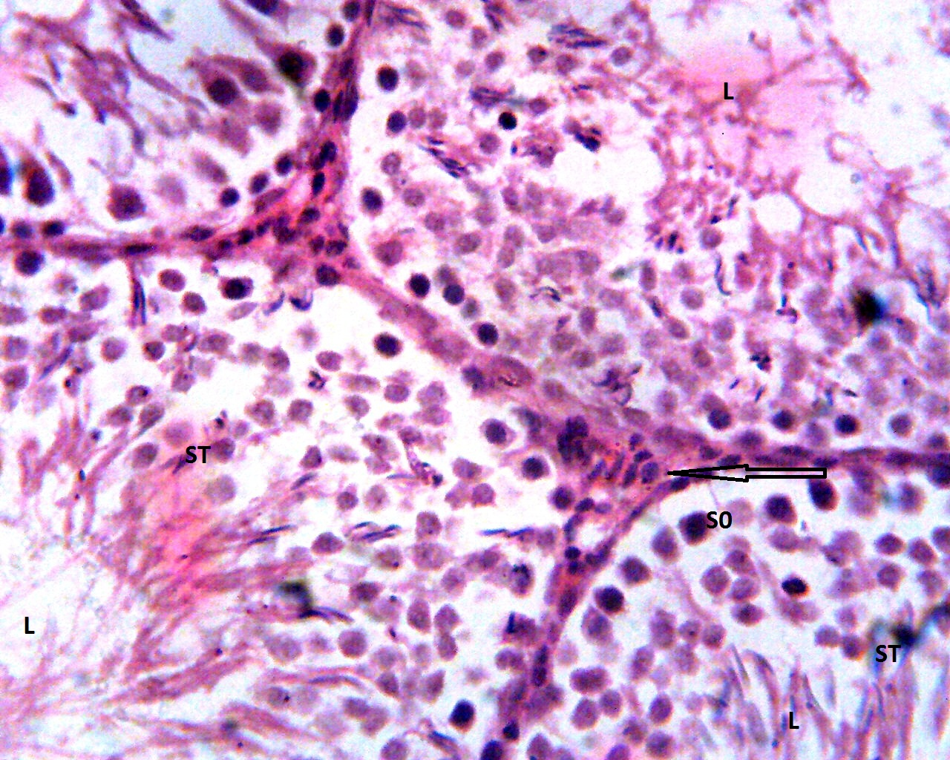

Figure 2A: Micrograph shows seminiferous tubules (ST) with a defined lumen (L), composed of spermatozoa. Tubules are composed of germ cells at different levels of maturation, the Sertoli cells and interstitial cells (arrow) appear essentially normal). Control Group Ovary
The well-defined columnar epithelium of the tubules predicts that the animal could have a good reproductive life. Ovary ovarian tissue with follicles at different stages of maturity around the cortical region, the medullary region is composed of blood vessels, nerves, and lymphatics. The tissue is supported by dense connective tissue and free of edema and infiltration Fig. 2B.
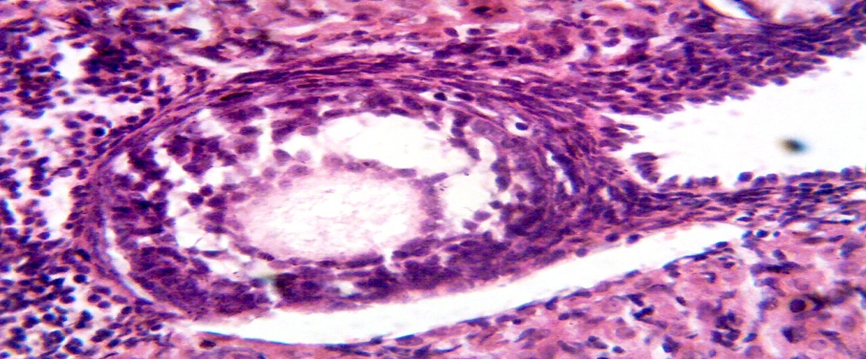
Figure 2B: Micrograph shows an ovarian tissue with follicles illustrating the various stages of maturity around the cortical region, the medullary region is composed of blood vessels, nerves, and lymphatics. The tissue is supported by dense connective tissue and free of edema and infiltration). Inactive Group Testis
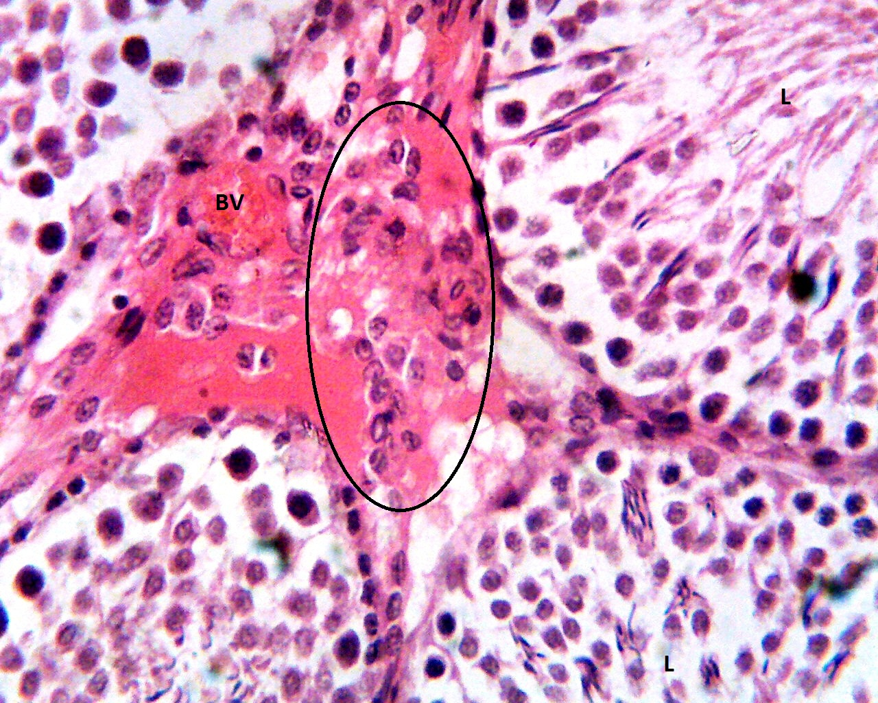

Figure 2C: Micrograph shows seminiferous tubules with reduced luminal spermatogenic (L) activities, marked hyperplasia of the interstitial cells of Leydig (circle) and congested blood vessel). Inactive Group Ovary
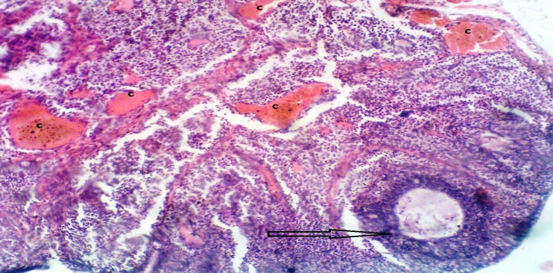
Figure 2D: Micrograph shows an ovarian tissue with a follicle (arrow) at different stages of maturity around the cortical region, the medullary region is composed of blood vessels nerves and lymphatics. The tissue is supported by dense connective tissue, however, foci of congestion (C) was seen around the cortical and medullary regions). Active Group Testis
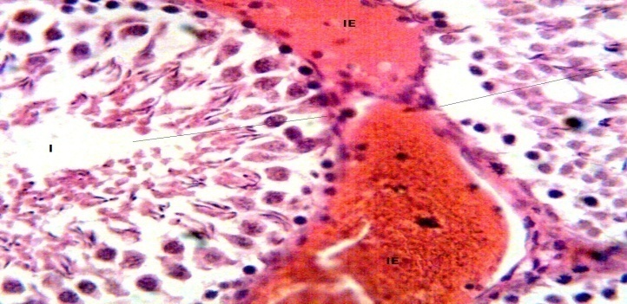
Figure 2E: Micrograph shows seminiferous tubules with reduced germ cells (line) and interstitial edema, also seen is sloughing of the germinal epithelium). Active Group Ovary
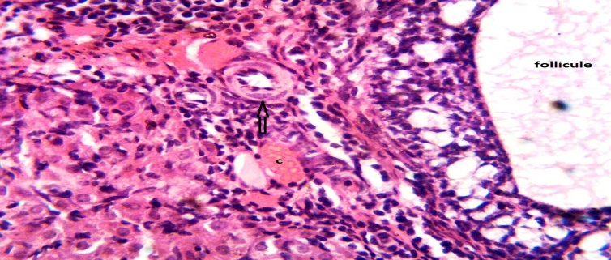
Figure 2F: Micrograph shows ovarian tissue with well-defined blood vessels (arrow) within the medullar and medullary congestion. The follicles appear unremarkable.
INACTIVE GROUP MALE AND FEMALE
The four weeks administration of Deca-Durabolin affected the normal histo-morphological appearance of the testis and ovaries when compared with the control. In the testes, germ cells in the lumen of the seminiferous tubules had a significant reduction in the formation and development, the Leydig cells adjacent to the seminiferous tubules were increased in size with numerous nuclei and congested blood vessel. The ovarian tissue was with ovarian follicles at various stages of maturation around the cortical region revealing that normal formation, development, and maturation of ova was taking place with a well-defined medullary region composed of blood vessels nerves and lymphatics. Ovarian tissue was supported by dense connective tissue; however,anomaly observed was foci of congestion around the cortical and medullary regions of the ovary.
ACTIVE GROUP MALE AND FEMALE
The four weeks administration of Deca-Durabolin affected the normal histomorphological appearance of the testes as the observation revealed seminiferous tubules with reduced germ cells (line) and interstitial edema, also seen was sloughing of the germinal epithelium. Ovarian tissue with well-defined blood vessels (arrow) within the medulla and medullary congestion. The follicles appear unremarkable.
DISCUSSION
In this study, we presented data revealing that intraperitoneal administration of Deca-Durabolin (5kg/BW) to experimental animals once a week for a period of 4-weeks induced histomorphological changes which are disadvantageous to the reproductive organs. Using ND means introducing testosterone, which belongs to a class of male hormones called Androgen into the body. Physiologically, it had been proven that females produced little quantity of testosterone secreted from the ovaries and adrenal glands. By implication, introducing more Androgen in form of a steroid increases androgenic activity in females that use such steroids. This investigation was in agreement with the research carried out by (Pan et al., 2016) which revealed that half of the women who received ND were with virilization. Observation from this study revealed changes in voice tone a characteristic feature of the virilization present in females exposed to physical activity. The experimental animals exposed to aerobic exercise responded differently, the male possessed higher swimming ability than the female (as shown in Fig 1) which could be a result of increased testosterone levels after receiving additional steroids from ND. Comparing both groups in Fig 1, it could be observed that statistical significant difference between the male female swimming ability was more in week two and three. However, the reasons behind the fall of the male swimming ability in the fourth week could not be attested to.

The reproductive organs are vital organs and as such, major substances that affect their morphology include drugs, heat, and hormonal imbalance. On account of this study, ND was discovered to have an adverse effect on the reproductive system. Histological analysis from this study showed abnormal changes in spermatogenic activities taking place in the seminiferous tubules (Fig 2E) alongside the Leydig cell (Fig 2C) which illustrates that the Leydig cell is a receptor of luteinizing hormone (LH); LH stimulates the Leydig cells to produce testosterone (Johnson & Creasy et al., 1972). The Leydig cells have a key function of secreting testosterone responsible for normal sperm production (Zirkin et al., 2012). Evaluation of this study revealed a decrease in LH receptors and testosterone secretion are responsible for reduced spermatogenic activities in the seminiferous tubules. Reduction of LH and testosterone affects spermatogenesis, consequently causes infertility. In consonance with their study? (Rahil et al., 2015) revealed a significant decrease in the Leydig cell population after administration of ND on long-term, short-term classes of mature and immature groups. Deduced from their study, it was observed that the testosterone concentration was reduced significantly except the short term mature group arose from an alteration in the normal function of Leydig cell, they further observed a decrease in Sertoli cell number, testicular size, the diameter of the seminiferous tubules were observed in the long term immature group. Eventually, a reduction in sperm population was noticeable in both probationary groups as well as significant depletion of sperm cells that occurred in the prolonged administration in comparison to the control group p< 0.05.

Furthermore, analysis from the inactive female Wistar rats revealed a well-defined ovarian tissue with foci of congestion around the cortical and medullary regions (Fig: 2D) which was not in consonance with (Karbalay-Doust et al., 2012); their study revealed a decrease in the size of the ovary, reduction in the cortex and medulla which was traced to reduction of oocytes when counted and follicles. However, the focus of congestion found in the course of this research is something new which could be a result of increased venous drainage to the ovaries. (Saddick et al., 2018) Deduced that during the first and second weeks of treatment with ND, the presence of relatively less primary follicles was noticed while more corpora luteal was observed at the expense of ovarian follicles. The study may have suggested that ND could result in alteration in the normal anatomy of the ovary. Various authors (García-Manso, 2016; Camargo CI et al. 2009) have reported that change in the morphology of ovarian tissues having follicular atresia, follicular unit disintegration, decreased oocyte count and elevation of the cortical stroma mediated by a rapid ovarian interstitial. These effects are the same reactions observed in the reproductive organs of the female exposed to steroids.

This research observed that the active male Wistar rats were present with the distorted reproductive system after introducing ND; interstitial edema observed in the animals could be as a result of fluid collection in the interstitial space,changing the normal activity of hormone production and regulation of spermatogenesis was shedding of the germinal epithelium was observed. In addition, a remarkable follicle with a definite blood vessel within the medullary was observed in active females. The medullar of the ovary is has a high vascularized stroma at the intermediary of the ovary. Congestion of the medullar seen in the active females (Fig 2F) could be as a result of engorgement of the blood vessels with blood.

CONCLUSION
The results of this experimental study revealed a significant adverse effect of the administration of ND on the reproductive organs (testis and ovary) of male and female models both the active and inactive groups. The normal doses of these drugs eventually lead to harmful effects on the testis and ovaries giving a clue that the use of ND poses a threat to the reproductive organ and has the ability to influence childbearing capacity. It was discovered that the voice of the female models experienced conspicuous changes in pitch and tone from sharp to dull.

DECLARATIONS

Acknowledgment
We sincerely wish to acknowledge Mr. Victor Ekundina of the Department of Medical Laboratory Science, Afe-Babalola University for a careful examination of the histological slides

Authors Contribution
Osahon RI and Ebeye OA conceived the research topic, drew the pattern and how the research would be done, Ehebha SE did all procurement of equipment, reagents used and assisted in drawing the research pattern. Dare NW did the first reading and made necessary corrections. All authors did the final editing of the manuscript.

Ethical approval and consent to participate
The Committee on Animal Ethics, Department of Anatomy, Delta State University Abraka, approved the feeding trial as well as the experimental protocol of this study. All of the experimental methodologies were in line in accordance with the directive from the National Institutes of Health Guide for the Care and Use of Laboratory Animals 2011.

Consent for Publication
Not applicable

Competing interest:
Authors declare that they have no competing interest

REFERENCES

Avwiworo O.G Histochemistry and tissue pathology principles and techniques. 2014 Third edition.

Belardin LB, Simao VA, Leite GAA, Chuffa LGDA, Camargo ICC. (2014). Dose-dependent effects and reversibility of the injuries caused by nandrolone decanoate in uterine tissue and fertility of rats. Birth Defects Research Part B Developmental and Reproductive Toxicology (BIRTH DEFECTS RES B) 101 (2), pp168–177.

Bhasin S, Storer TW, Berman N, Callegari C, Clevenger B, Phillips J, Bunnell TJ, Tricker R, Shirazi A, Casaburi R. (1996) The effects of supraphysiologic doses of testosterone on muscle size and strength in normal men.The New England Journal of Medicine 335, pp-1–7.

Bird S, Greaves RF, Burke LM, Goebel C. (2016) Doping in sport and exercise: anabolic, ergogenic, health and clinical issues. Annals of Clinical Biochemistry. 53, pp196–221.

Camargo CI, Barreiros De Souza R, Mesquita SFP, Chuffa, L, Frei, F. (2009) Ovarian histology and follicular score in female rats treated with nandrolone decanoate and submitted to physical effort. Acta BiologicaHungarica 60(3), pp:253–261.

Camargo ICC, Leite GAA, Pinto T, Ribeiro-Paes JT. (2014) Histopathological findings in the ovaries and uterus of albino female rats promoted by co-administration of synthetic steroids and nicotine. Experimental and Toxicologic Pathology 66(4), 195–202.

Creasy DM., Chapin RE., (2013) Male Reproductive System. Haschek and Rousseaux’s Handbook of Toxicologic Pathology.
Ebeye OA, Ekudina VO, Osahon RI. (2016). The Histomorphological and physical effect of Nandrolone Decanoate on the hepatorenal tissues of adult Wistar rat exposed physical activity. European Journal of Pharmacological and Medical Research. 3(5), pp-285-289.

Forbes, GB. (1985) The effect of anabolic steroids on lean body mass: the dose-response curve.Metabolism. 34, pp-571–573.

Frati P, Busardò FP, Cipolloni L, Dominicis ED, Fineschi V. (2015) Anabolic Androgenic Steroid (AAS) related deaths: autoptic, histopathological and toxicological findings. Current Neuropharmacology13,146–159.

García-Manso JM., Esteve TV. (2016) Consequences of the use of anabolic-androgenic steroids on female athletes’ fertility. In: Exercise and Human Reproduction. Springer.

Johnson LG, Fisher G, Silvester LJ, Hofhein CC. Anabolic steroid: effect on strength, body weight, oxygen uptake and spermatogenesis upon mature males.Medicine& Science in Sports & Exercise. 1972;4(4) pp-3-5.

Karbalay-Doust S, Noorafshan. A., (2012) Stereological estimation of ovarian oocyte volume, surface area and number: application on mice treated with Nandrolone Decanoate.Folia HistochemCytobiol. 50(2):275-279.

Pan MM, Kovac JR., (2016) Beyond testosterone cypionate: the evidence behind the use of Nandrolone in male health and wellness”. 5(2): 213-9.

Rahil, J., Saeed, S., Ahmad, F. (2015) Effect of supraphysiological dose of Nandrolone Decanoate on the testis and testosterone concentration in mature and immature male rats: A time-course study. International Journal of
Reproductive Biomedicine 13(12), 779-786.

Saddick, S.Y. (2018) The impact of nandrolone decanoate administration on ovarian and uterine tissues in the rat: Luteinizing hormone profile, histopathological and morphometric assessment. Saudi Journal of Biological Sciences.; 25(3), 507–512.
Simão, V.A., Belardin, L.B., Leite, G.A.A., Chuffa, L.G.A., Camargo ICC.(2015) Effects of different doses of nandrolone decanoate on estrous cycle and ovarian tissue of rats after treatment and recovery periods. 96 (5): 338–349.

Tamara, R.N., Vladimir, I.Z., Ivan, M.S. (2017) Acute effects of Nandrolone Decanoate on cardio dynamic parameters in isolated rat heart. Canadian Journal of Physiology and Pharmacology. 94.

Tanehkar, F., Rashidy-Pour, A., Vafaei, A.A., Sameni, H.R., Haghighi, S., Miladi-Gorji, H., Bavarsad, K. (2013) Voluntary exercise does not ameliorate spatial learning and memory deficits induced by chronic administration of nandrolone decanoate in rats. Hormones and Behavior63(1), pp-158–165.

Zirkin BR. (1998) It’s regulation by testosterone and FSH Semin cell.Developmental Biology. 9:417-21.

