*Case Study*

**Role of Bronchoscopy in Emergency Department in Persistent Acute Type II Respiratory Failure**

**Faizatul Asna Abd Aziz*, Gurjeet Singh a/l Harvendhar Singh**

**Hospital Selayang, Lebuhraya Selayang -Kepong, 68100 Batu Caves, Selangor, Malaysia**

**\*Corresponding Author’s Email: faizatulasna@gmail.com**

**Abstract**

Persistent difficulty in ventilation, particularly in mechanically ventilated patients, despite appropriate pharmacological intervention, poses a significant clinical challenge and demands immediate attention to prevent deterioration and further complications. One of the key approaches in such situations involves the physical assessment of the airway using bronchoscopy, which serves not only as a diagnostic modality but also as a potential therapeutic tool. Flexible bronchoscopy allows for direct visualization of the tracheobronchial tree, helping to identify obstructive secretions, mucous plugging, foreign bodies, or anatomical abnormalities that may be contributing to inadequate ventilation. Based on the initial visual findings during bronchoscopy, emergency physicians can proceed with appropriate therapeutic maneuvers such as suctioning of secretions, lavage, or removal of obstructions. This timely intervention can significantly improve patient outcomes by restoring adequate ventilation and preventing progression to respiratory arrest or multisystem involvement. Therefore, the use of bronchoscopy in the Emergency Department (ED) should not be delayed, especially in cases of persistent Acute Type II Respiratory Failure, where hypercapnia and ventilatory failure persist despite initial management. Emergency physicians and residents trained in bronchoscopy should be encouraged to incorporate this tool early in the clinical decision-making process. Prompt deployment of bronchoscopy in acute settings can mitigate critical ventilatory issues and offers a vital bridge between diagnosis and treatment, especially when time is of the essence. Integrating bronchoscopy into standard emergency protocols has the potential to enhance airway management and improve the overall prognosis in critically ill patients presenting with complex respiratory failure.

**Keywords:** Acute Type II Respiratory Failure; Airway Management; Bronchoscopy; Emergency Department; Mechanical Ventilation

**Introduction**

Acute Type II respiratory failure, characterized by hypercapnia and hypoxemia, is commonly observed in critically ill patients and can emerge in the context of severe systemic conditions such as sepsis or hypermetabolic states triggered by severe pneumonia (Almanza-Hurtado et al., 2022). While this condition is often managed with pharmacological interventions and mechanical ventilation strategies, a lack of response to standard treatment protocols warrants further investigation into alternative or compounding causes. One such cause, which is frequently under-recognized in acute settings, is acute airway obstruction due to mucus plugging, secretions, or foreign body aspiration.

In such scenarios, bronchoscopy emerges as a valuable diagnostic and therapeutic tool. Traditionally, the use of bronchoscopy has been predominantly confined to controlled environments such as the intensive care unit (ICU) or operating theatre, where its application is well-documented for managing airway-related complications (Elizalde-González, 2023). However, in recent years, there has been a notable shift toward the utilization of flexible bronchoscopy within Emergency Departments (EDs). Emergency physicians are increasingly recognizing its value, particularly in complex respiratory cases where rapid airway assessment and intervention can significantly alter the clinical trajectory. Several studies and clinical reports have supported this emerging trend, highlighting its efficacy and safety in the hands of trained ED professionals (Adi et al., 2022; Lee et al., 2022; Singh, 2023).

This case report underscores the critical role of flexible bronchoscopy in the ED setting for a patient presenting with severe pneumonia complicated by persistent Type II respiratory failure. It emphasizes the need for timely airway evaluation in unresponsive cases and supports the growing role of emergency physicians in deploying bronchoscopy as both a diagnostic and therapeutic measure outside traditional ICU boundaries.

**Case Presentation**

A 73-year-old female with a known medical history of diabetes mellitus, hypertension, and chronic kidney disease presented to the Emergency Department (ED) following a two-day history of general malaise, productive cough, and acute confusion on the day of admission. On arrival, the patient was febrile, disoriented, and in evident respiratory distress. Her oxygen saturation was critically low at 60% on room air, which improved only modestly to 90% despite administration of high-flow oxygen via a non-rebreather mask at 15 L/min. Lung auscultation revealed generally reduced air entry over bilateral lung fields.

Recognizing the signs of acute respiratory failure and compromised airway protection, rapid sequence intubation was performed, and the patient was initiated on mechanical ventilation. A chest X-ray demonstrated bilateral pulmonary consolidation consistent with pneumonia. The endotracheal tube (ETT) was confirmed to be in situ, and no evidence of pneumothorax or pleural effusion was observed. Empirical treatment was commenced with intravenous penicillin and an oral macrolide for severe community-acquired pneumonia, further complicated by septic shock requiring inotropic support in the form of a noradrenaline infusion.

An arterial blood gas (ABG) analysis performed post-intubation showed acute decompensated Type II respiratory failure, with a pH of 7.11 and a markedly elevated PaCO₂ of 91 mmHg. A ventilatory strategy tailored for obstructive lung pathology was employed in an attempt to correct respiratory acidosis. Despite ongoing management, including intravenous antibiotics, nebulized bronchodilators, and frequent ventilator setting adjustments, the patient’s PaCO₂ rose precipitously to 126 mmHg within 12 hours, accompanied by a further drop in pH to 7.02.

Initial suctioning via the ETT successfully evacuated copious secretions, which eventually diminished. No mechanical obstruction was evident upon routine checks. In an effort to optimize bronchial dilation, an intravenous propofol infusion was commenced alongside ongoing midazolam and fentanyl sedation.

Approximately 24 hours after ED presentation, a flexible bronchoscopy was performed via the ETT. This revealed dense, adherent yellowish, crusted mucoid impactions obstructing both the right (Figure 1) and left main bronchi (Figure 2-3). Multiple attempts at suctioning and lavage with normal saline were undertaken and successfully dislodged and removed the mucus plugs.

Following the procedure, significant clinical and ventilatory improvement was observed. Ventilator readings showed decreased peak inspiratory pressure (PIP) and peak airway pressure (Ppeak), suggesting improved airway patency. Furthermore, repeat ABG analysis demonstrated a marked reduction in PaCO₂ to 50 mmHg, along with decreased oxygen requirements, indicating substantial improvement in ventilation and gas exchange.

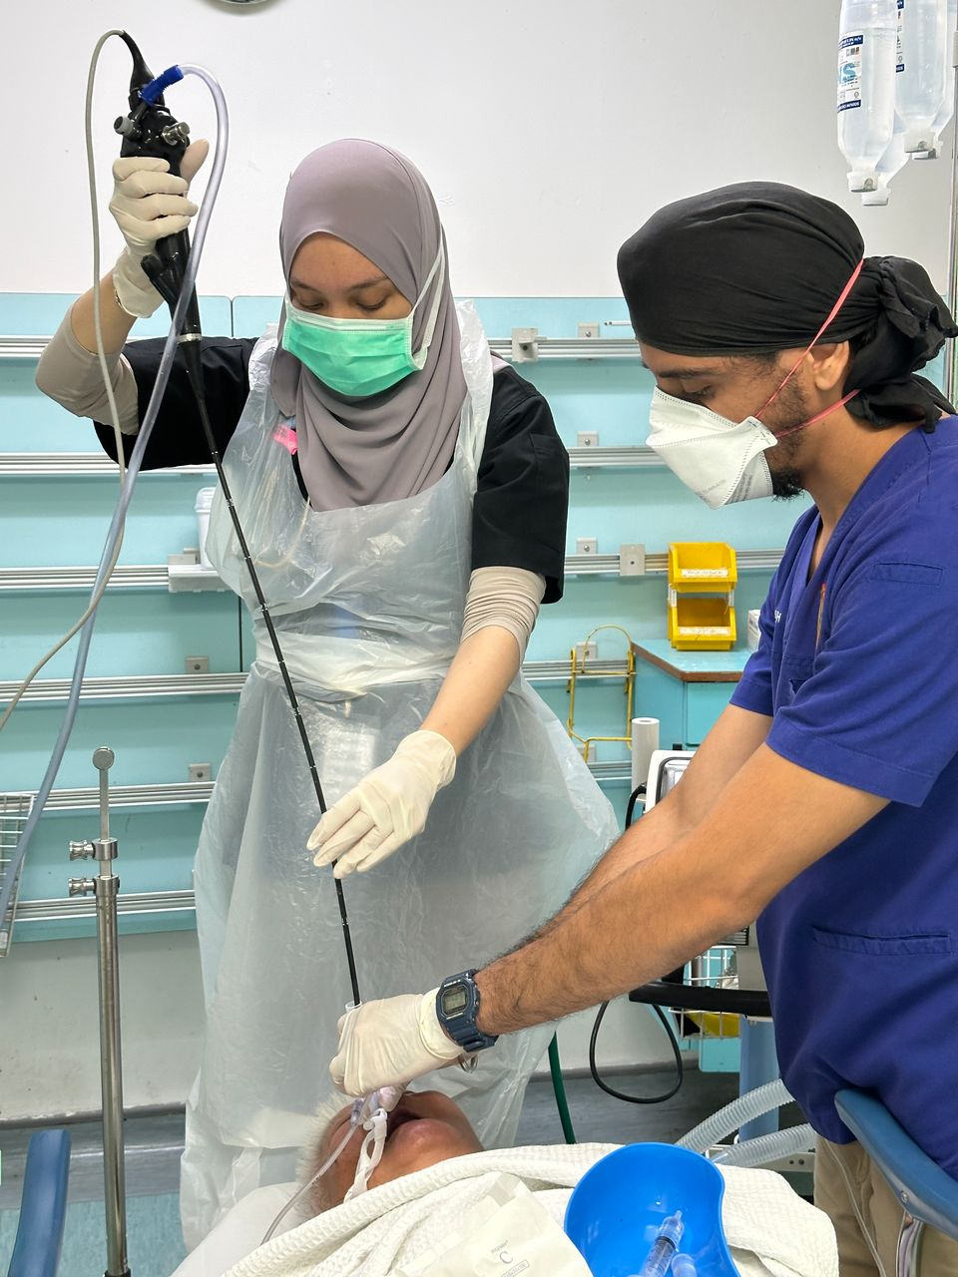

***Figure 1: Performing the Bronchoscope***

***Figure 2: Crusted Mucous in Right Main Bronchus***

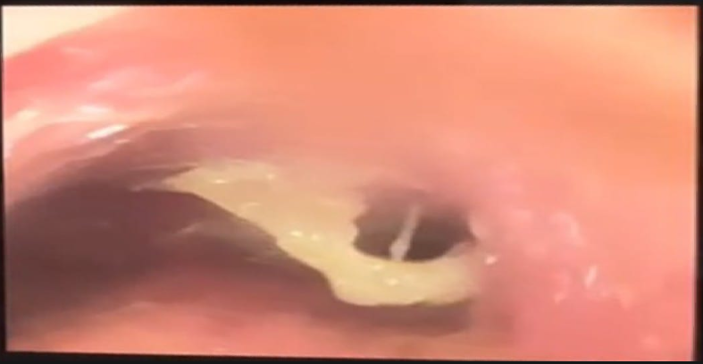

***Figure 3: Crusted Mucous in Right Main Bronchus***

**Discussion**

Mucus is composed of water and elastic solid components, and its physical characteristics can change in response to underlying pathological processes as well as mechanical ventilation. These alterations may contribute to the formation of tenacious secretions that obstruct the trachea and bronchi (Che Omar, 2021). Over time, in the absence of adequate humidification during mechanical ventilation, mucus can become thickened and crusted within the tracheobronchial tree. This can lead to significant airway obstruction, posing a major challenge in managing ventilated patients.

Such mucous impaction may not be readily visible or suspected during routine clinical examination but can manifest as persistent airway obstruction, worsening respiratory failure, or even extubation failure. These subtle presentations often complicate timely diagnosis and may lead to the condition being missed or underreported (Qian et al., 2023). In a retrospective analysis conducted at a tertiary care center, focusing on laryngo-tracheo-bronchial foreign bodies, it was found that 17% of patients were diagnosed with mucus, mucous plugs, crusting, or mass-like lesions identified via rigid bronchoscopy (Puvvada et al., 2024).

Historically, bronchoscopy was introduced in 1897 as a tool to extract foreign bodies through the translaryngeal route and to visualize airway anatomy (Becker, 2017). In modern clinical practice, both flexible and rigid bronchoscopy are considered the gold standard diagnostic and therapeutic modalities for evaluating and managing foreign body airway obstruction (FBAO) (Kaddah & Ahmed, 2015). In addition to foreign body removal, bronchoscopy is also widely utilized for various other indications, including detailed airway assessment, evaluation of unexplained lobar collapse, and resolution of atelectasis.

Despite its broad utility, bronchoscopy is predominantly employed in controlled environments such as the operating theatre or intensive care unit (ICU), where optimal procedural safety can be ensured (Kabadayi & Bellamy, 2017). However, its use in the Emergency Department (ED) remains relatively underutilized, even though it is a minimally invasive and generally safe procedure. Adi et al. (2022) demonstrated the effectiveness of bronchoscopy in the ED for managing post-intubation refractory hypoxia in patients suspected of having foreign body airway obstruction.

Recent data further highlight a significant rise in bronchoscopy use in the ED setting. A longitudinal study by Lee et al. (2022) reported an increase in its usage from 23% in the early years of a 10.5-year study period to 77% in the latter half, reflecting the growing proficiency and confidence of emergency physicians in handling bronchoscopic equipment.

The procedure itself can be completed rapidly, often within approximately 60 seconds, making it highly advantageous in acute emergency scenarios. In cases where patients experience difficulty in oxygenation despite optimized ventilatory settings, bedside bronchoscopy can effectively remove mucous plugs, restoring airflow and improving ventilation (Singh, 2023). Therefore, for mechanically ventilated patients experiencing unexplained ventilatory compromise, early deployment of bronchoscopy in the ED can serve as a critical intervention while awaiting ICU admission.

**Limitations**

This report is based on a single patient case and may not be generalizable to all clinical settings or patient populations. The absence of long-term follow-up data limits the ability to assess sustained outcomes after bronchoscopic intervention. Additionally, access to bronchoscopy and physician expertise may vary across emergency departments, potentially affecting the feasibility and reproducibility of such interventions in resource-limited settings.

**Conclusion**

Critically ill patients on mechanical ventilation often require advanced interventions beyond standard pharmacological and ventilatory strategies. In cases where ventilatory difficulties persist despite optimal management, the possibility of crusted mucoid impaction within the tracheobronchial tree should be strongly considered. This underrecognized complication can significantly hinder gas exchange and contribute to worsening respiratory failure. The use of flexible bronchoscopy in the emergency department, when performed by trained emergency physicians, has proven to be a valuable diagnostic and therapeutic tool. It allows for the timely identification and removal of airway obstructions, leading to rapid clinical improvement and stabilization.

As emergency medicine continues to evolve, the integration of bronchoscopy into standard ED practice presents a promising avenue for enhancing the care of mechanically ventilated patients. Future initiatives should focus on increasing access to bronchoscopic equipment in emergency settings, expanding formal training for emergency physicians, and developing standardized protocols for its use. Further research, including prospective studies and multicenter analyses, is warranted to better understand the outcomes, safety, and cost-effectiveness of bronchoscopy in the ED. Ultimately, broader implementation of this procedure may significantly improve the management of acute respiratory failure and reduce dependence on intensive care resources.

**Conflict of Interest**

The authors declare that there have no conflict of interest.

**Acknowledgement**

The authors are thankful to the institutional authority for completion of the work

**References**

Adi, O., Baherin, M. F., Fong, C. P., Fatan, A. A. A., Ahmad, A. H., Yusof, A. A., & Khan, F. A. (2022). Emergency physician-performed emergency bronchoscopy in cardiac arrest patient due to acute foreign body airway obstruction. *The American Journal of Emergency Medicine*, *53*, 23-28. <https://doi.org/10.1016/j.ajem.2021.12.027>

Almanza-Hurtado, A., Polanco Guerra, C., Martínez-Ávila, M. C., Borré-Naranjo, D., Rodríguez-Yanez, T., & Dueñas-Castell, C. (2022). Hypercapnia from physiology to practice. *International Journal of Clinical Practice*, *2022*(1). <https://doi.org/10.1155/2022/2635616>

Che Omar, S. B. (2021). Airway Obstruction by a Mucous Plug in a Ventilated Child A Case Review. *Journal of Clinical and Medical Images*, *5*(9), 1-4. Retrieved from: <https://clinandmedimages.org/wp-content/uploads/2021/05/JCMI-v5-1436.pdf>. Accessed on 29th January 2025.

Elizalde-González, J. J. (2023). Bronchoscopy in the ICU. Simple procedures in difficult cases. *Medicina Crítica*, *37*(2), 66-68. <https://dx.doi.org/10.35366/110437>

Ernst, A., & Herth, F. J. (Eds.). (2017). *Introduction to bronchoscopy*. Cambridge University Press. <https://doi.org/10.1017/9781316084182>

Kabadayi, S., & Bellamy, M. C. (2017). Bronchoscopy in critical care. *BJA Education*, *17*(2), 48-56. <https://doi.org/10.1093/bjaed/mkw040>

Kaddah, S., & Ahmed, S. (2015). Management of airway foreign body using flexible bronchoscopy: Experience with 80 cases during 2011–2013. *Egyptian Journal of Chest Diseases and Tuberculosis*, *64*(1), 261-267. <https://doi.org/10.1016/j.ejcdt.2014.11.020>

Lee, D. H., Driver, B. E., Prekker, M. E., Puskarich, M. A., Plummer, D., Mojica, E. Y., ... & Reardon, R. F. (2022). Bronchoscopy in the emergency department. *The American Journal of Emergency Medicine*, *58*, 114-119. <https://doi.org/10.1016/j.ajem.2022.05.040>

Puvvada, V. S. K., Ramesh, M., Chilaka, R. T., Dhanalaxmi, D., Puvvada, C. S., & Puvvada, V. (2024). Retrospective Analysis of Laryngo-Tracheo-Bronchial Foreign Bodies in a Tertiary Care Setting and Insights on AI Detection Methods. *European Journal of Cardiovascular Medicine*, *14*, 885-889. Retrieved from: <https://www.healthcare-bulletin.co.uk/article/retrospective-analysis-of-laryngo-tracheo-bronchial-foreign-bodies-in-a-tertiary-care-setting-and-insights-on-ai-detection-methods-2369/>. Accessed on 29th January 2025.

Qian, K., Wei, Y., Liu, X., Li, Z., Cao, S., Wen, D., ... & Zhang, Y. (2023). A missed diagnosis of sputum crust with fiberoptic bronchoscope causing extubation failure: a case report. *BMC Pulmonary Medicine, 23*(1), 153. <https://doi.org/10.1186/s12890-023-02457-w>

Singh, G. (2023). Significance of Emergency Bronchoscopy; Significance in Essential Emergency Critical Care Setting. *Malaysian Journal of Medical Research (MJMR)*, *7*(2), 40-44. <https://doi.org/10.31674/mjmr.2023.v07i02.006>