Green Nano cosmeceuticals: Formulating an Eco-Friendly, Preservative-Free Cucumber and Chamomile Oil Nano emulsion for Advanced Skin Therapeutics
Iman Zafri Bin Zai Izzuddin Sham, Roshen Roy A/L A Stephan, Gary Fong Jun Ming, Eniola Oyetola Fatokun, Heashem Al Ansary, Yoganitha A/P Ponnuthurai, Satheesh Babu Natarajan, Nivetha Shanmugam*.
School of Pharmacy, Lincoln University College, Selangor, Malaysia.

ABSTRACT:
The increasing consumer demand for safe, sustainable, and effective skincare has intensified the development of green cosmeceuticals, integrating natural botanicals with advanced delivery systems. This study reports the formulation and characterization of a preservative-free, eco-friendly cucumber (Cucumis sativus) and chamomile (Matricaria chamomilla) oil nanoemulsion face mist designed for enhanced skin hydration, elasticity, and protection against oxidative damage. Utilizing Tween 80 as a non-ionic surfactant, three formulations differing in chamomile oil concentration (0.1% w/w, 0.2% w/w, and 0.3% w/w) were prepared via high-speed homogenization. Physicochemical evaluations revealed stable nanoscale droplets (296–737 nm), moderately negative zeta potentials (−6.9 to −11.1 mV), pH values consistent with the skin’s acid mantle (4.61–5.56), and low viscosity conducive to fine mist application. Stability assessments-freeze–thaw, thermostability, and centrifugation tests-confirmed the nanoemulsions’ robustness without synthetic preservatives. The antioxidant activity of cucumber extract showed strong, concentration-dependent free radical scavenging with up to 79% inhibition at 2000 µg/mL. skin analysis demonstrated significant improvements in hydration, oil content, and elasticity, particularly at 0.3% w/w chamomile oil concentration. Spray characteristics and drying time tests indicated optimal sensory properties facilitating consumer acceptability. These findings establish the promising potential of cucumber and chamomile oil nanoemulsion as a green, preservative-free cosmeceutical platform that aligns with current industry trends towards natural, sustainable, and efficacious skincare solutions.
Keywords: cucumber extract, chamomile essential oil, Nano emulsion, face mist, skin.
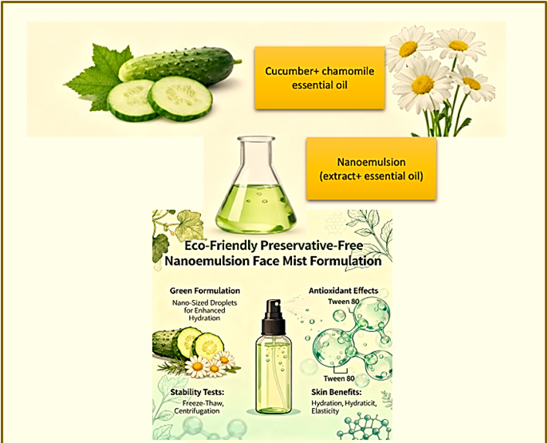
Graphical abstract:

- Introduction
Skin, the largest organ of the human body, constitutes a complex multilayered system vital for protection against environmental insults, pathogens, ultraviolet radiation, and dehydration, while also regulating thermoregulation, sensory perception, and immune responses (1,2). Given ,its critical biological functions, skin health directly influences overall well-being and social confidence, amplifying the significance of effective cosmetic interventions that go beyond aesthetic enhancement (3,4).
The cosmetic industry profoundly impacts consumer health and psychology; however, adverse reactions such as allergic dermatitis and irritation continue to challenge safety profiles, particularly in formulations using synthetic preservatives and chemicals (3,4). This has catalysed a paradigm shift towards natural-source cosmetics grounded in phytoconstituents with inherent biological activities, aligning with the rising consumer demand for clean-label, "green" herbocosmeceuticals that minimize chemical exposure while maximizing therapeutic benefits (5,6).
Among popular cosmetic formulations, face mists offer versatile hydration and sensory rejuvenation; yet, traditional water-based sprays often suffer from the instability of bioactive compounds and reliance on synthetic preservatives that may elicit sensitivities (7,8). The development of preservative-free aqua-based formulations, leveraging natural antimicrobial components and advanced encapsulation technologies, represents a sustainable innovation that meets consumer demand for eco-conscious, gentle products without compromising efficacy (9,10).
Phytochemicals such as flavonoids, phenolics, terpenoids, and antioxidants serve fundamental roles in mitigating oxidative damage, inflammation, and microbial colonization on skin surfaces, thus securing skin health and cosmetics’ therapeutic potentials (5,11). Economically, the natural cosmetics market is experiencing exceptional growth-projected to reach unprecedented valuations by 2035- driven by consumer preference for botanically sourced actives with validated efficacy profiles (6,11).
Cucumber (Cucumis sativus) extract is a classic dermo cosmetic ingredient providing exceptional hydration, antioxidant activity, and skin-calming effects, attributable to its rich water content, vitamins C, K, and E, as well as polysaccharides and caffeic acid derivatives (7,12). Chamomile oil, rich in bioactive flavonoids and sesquiterpenes such as bisabolol and chamazulene, exhibits potent anti-inflammatory, antimicrobial, and anti-inflammatory effects that aid in reducing acne, eczema, and aging signs, thus conferring multifaceted dermal benefits (8,13).
However, conventional face mists fail to maximize these benefits due to poor skin penetration and rapid evaporation. Nanotechnology, specifically nanoemulsion systems, surmount these limitations by enhancing bioavailability, providing sustained release of actives, improving thermodynamic stability, and augmenting skin hydration and barrier functions (9,14). The use of nanoemulsion for face mist formulates stable, translucent spray products with fine droplet sizes enabling superior skin adherence without tackiness or residue (9,14).
Moreover, adopting green technology principles in herbocosmetics emphasizes using eco-friendly solvents, energy-efficient processes, and biodegradable materials, promoting formulations that are fully aqueous and preservative-free while relying on intrinsic antimicrobial properties and product packaging innovations such as airless spray systems to extend shelf life (10,11). Such innovations advance sustainability without compromising product safety or consumer experience, setting new standards in cosmetic science and environmental stewardship (9,11).
The development of a cucumber extract and chamomile oil nanoemulsion face mist blends these scientific and consumer-driven trends. It combines botanical efficacy with nanobiotechnology and green cosmetology to deliver a potent, safe, and sustainable skincare solution. Success in this endeavour hinges on meticulous optimization of nanoemulsion parameters, such as droplet size, polydispersity index, encapsulation efficiency, rheological properties, and sensory attributes, coupled with thorough microbiological safety assessments without conventional preservatives (10,14). Integration of in vitro skin permeation studies and in vivo efficacy validation will further cement its market potential.
In summary, this formulation underscores how contemporary cosmetic science can leverage natural bioactives, nanotechnology, and green chemistry to meet escalating consumer demands for safe, environmentally responsible, and effective skincare products. Continued innovation and rigorous scientific validation are essential pillars to translate these advances from laboratory scale to commercial success.

- Literature Review
Cucumber, scientifically known as Cucumis sativus(18), is a creeping vine plant that bears cucumber fruits. A study on cucumber-derived ingredients, which included cucumber extract, fruit, fruit water, juice, seed extract, and fruit extract, found that they function in cosmetics as skin-conditioning agents (19) displaying cooling, healing, soothing, and emollient effects(18). One of cucumber extract's most important traits in the context of skin health is that it possesses antioxidant (20) and amylolytic (21) properties. When attempting to obtain cucumber extract, the methods employed in the extraction process have shown to have an effect on the observed biological properties of the resulting extract. This is seen in a study by Foong et al., in which the peel & pulp of cucumber were extracted from aqueous & phosphate buffered saline (PBS) solutions at 37°C for 8 hours (similar to normal human physiological temperature)(18). It was observed that the aqueous extract did not show any antibacterial activity, while the PBS extracts exhibited antimicrobial activity against Staphylococcus aureus and Klebsiella pneumoniae. Aqueous cucumber extract contains flavonoids, saponins and steroids which all play a role in maintaining skin health— flavonoids and tannins (phytochemicals) in aqueous cucumber extract might contribute to free radical scavenging, analgesic, and anti-inflammatory activities —and therefore provide benefits for use in a face mist formulation (18). Another point to note about cucumber extract is its ability to reduce pain and inflammation in patients with knee osteoarthritis(22).

Chamomile (M. chamomilla) is a herbaceous plant from the family Asteraceae. It is classified as an essential oil, which can be described as aromatic, volatile, lipophilic liquids extracted from different parts of plant materials such as barks, buds, flowers, fruits, seeds, and roots(23). One study on the anti-inflammatory effects of chamomile oil, 3 oils were extracted from aerial parts of the chamomile plant by hydro distillation(24). The main metabolites of chamomile oils are terpenoids, with the most important compounds being bisabolol, farnesene, spathulenol, Spiro ethers and azulenes such as chamazulene(25). The quality of chamomile oil may generally be determined through visual observation of its blue colour, indicating a good amount of terpenoids present in the oil. Additionally, the environment in which the chamomile was grown can have an impact on the antioxidative properties of its oil. Parameters such as irrigation, location, soil properties, and altitude all play a role in this respect. It has been observed that chamomile plants grown at high altitudes and in high fertility, rainfed environments produce a high number of flowers, resulting in a larger amount of oil collected. The quality of the oil is also higher, with better phytochemical composition and stronger antioxidant activity(23). In one study, researchers found that chamomile oil inhibits inflammation by modulating human immune cells' activity through the inhibition of M1 macrophages (immune cells that produce inflammation). This study also showed that chamomile oil boosts the endogenous antioxidant defence system, helping the body make more natural antioxidant enzymes(23). Chamomile oil has also been observed to possess antimicrobial properties, showing activity against both gram-positive and gram-negative bacteria(25). Hence, other than having anti-inflammatory and antioxidant properties, chamomile oil also possesses antimicrobial action.
Face mist is one of the various cosmetics on the market that is sold in the form of a spray. Its main function is to act as a refresher and moisturizer once it's sprayed directly onto the skin(26). They are quickly absorbed into the skin and have the ability to remove residual oil from the skin(27). According to multiple studies done on face mists, the most common ingredients present in its formulation are water, essential oils, surfactants, and preservatives. Surfactants such as tween-80, also known as polysorbate-80 may be added to face mists in order to solubilize oil components in water and ensure that any active ingredients are being dispersed uniformly onto the skin. In addition, surfactants also prevent the separation of the components of the emulsions, giving them a smooth and even property(28).
- Materials and Methods
Materials
Cucumber extract (Cucumis sativus L.) and chamomile essential oil (Matricaria chamomilla L.) were used as principal active agents. Polysorbate 80 (Tween 80) served as the non-ionic surfactant and emulsifying agent. Analytical-grade methanol and distilled water were utilized throughout the experiment. DPPH (2,2-diphenyl-1-picrylhydrazyl) was employed to assess free radical scavenging activity. All reagents and solvents met the required purity standards for analytical and cosmetic formulation studies.
Apparatus
The study utilized an electronic analytical balance (Sartorius, Germany), a high-speed homogenizer, Anton Paar dynamic light scattering (DLS) particle size analyzer equipped with zeta potential measurement software, a rotational rheometer (Brookfield), a bench-top pH meter, a UV–Visible spectrophotometer (Shimadzu UV-1800), refrigerated centrifuge, stability chambers for temperature cycling, and a portable skin analyzer.
Nanoemulsion formulations were packaged in sterile airless mist bottles to minimize contamination and oxidative degradation.
Preparation of cucumber extract:
Cucumber extract was prepared by slicing the cucumber into pieces and grounded with 200 ml of water and filtered. The extract was used for preparation of nanoemulsion.
Formulation of the Nanoemulsion Face Mist
Three nanoemulsion formulations were prepared with increasing concentrations of chamomile oil (0.1%, 0.2%, and 0.3% w/w) while maintaining cucumber extract at 5% w/w and Tween 80 at 0.2% w/w (Table 1). The remaining content consisted of distilled water to achieve a fully aqueous matrix.

Table 1. Composition of cucumber-chamomile nanoemulsion formulations
Ingredient(w/w) | F1 | F2 | F3
Cucumber extract (g) | 5 | 5 | 5
Chamomile oil (g) | 0.1 | 0.2 | 0.3
Tween 80 (g) | 0.2 | 0.2 | 0.2
Distilled water (g) | 94.7 | 94.6 | 94.5
Preparation of Nanoemulsion
Distilled water was first transferred into a beaker placed under constant stirring at 360 rpm using the homogenizer. Cucumber extract was then added gradually to form a uniform aqueous dispersion. Separately, chamomile oil was premixed with Tween 80 to ensure complete solubilization of the lipophilic component. This oil-surfactant blend was introduced dropwise into the aqueous phase under continuous stirring while gradually increasing homogenization speed to 545 rpm. Following complete addition, the mixture was homogenized at 800 rpm for 10 minutes to achieve a translucent, stable nanoemulsion. The resulting formulations were collected in airtight mist bottles and stored at 25°C before evaluation.
- Evaluation of Physicochemical Properties
Organoleptic characteristics: Formulations were assessed visually and olfactorily for appearance, colour, phase uniformity, and odour both initially and throughout stability testing.
Particle size and zeta potential: Particle size distribution and surface charge were quantified using dynamic light scattering (DLS). Each sample was analyzed in triplicate at 25°C.
Homogeneity and spray characteristics: Homogeneity was assessed by spraying from 5 cm onto a glass slide, observing consistency of atomization. The spray pattern was measured by spraying onto filter paper and recording the mean diameter of dispersion.
pH determination: The pH was measured at ambient temperature using a calibrated pH meter. The target pH range for dermal applications was maintained between 4.5 and 6.5 to sustain the skin’s acid mantle.
Viscosity measurement: Rheological behaviour was quantified using a rotational viscometer at 25°C. The obtained values were expressed in mPa·s.
Skin parameter analysis: Skin hydration, sebum content, and elasticity were monitored using a skin analyzer before and after application. Measurements were taken at baseline, immediately after application, and at 15-minute intervals up to one hour to evaluate the short-term moisturizing and elastic recovery potential of each formulation.
Drying time: A chronometric assessment was performed on a defined 5 cm² skin area, measuring the time required for complete evaporation without residue. Distilled water served as the control.
Stability Assessment
Freeze–thaw test: Samples were cycled between −20°C and 25°C for 24-hour intervals over three cycles to assess phase separation, precipitation, and colour changes.
Thermostability test: Thermal stress was simulated by alternating between 40–50°C and 3–5°C for 24-hour intervals over three cycles.
Centrifugation test: Samples were centrifuged at 3000 rpm for 30 minutes to identify phase instability.
Antioxidant Activity
Antioxidant activity was evaluated using the DPPH radical scavenging assay. A 0.1 mM DPPH solution in methanol was prepared. Nanoemulsion samples at four concentrations (C1–C4) were incubated with DPPH solution in the dark for 30 minutes before absorbance measurement at 517 nm. A negative control containing only DPPH and methanol was prepared to compute the percentage inhibition.

- Results and Discussion
Physicochemical Characteristics
All formulations exhibited uniform whitish translucency with no evidence of phase separation (Figure 1), flocculation, or sedimentation throughout preparation and storage. The absence of turbidity or oil film signified efficient droplet dispersion and emulsification.
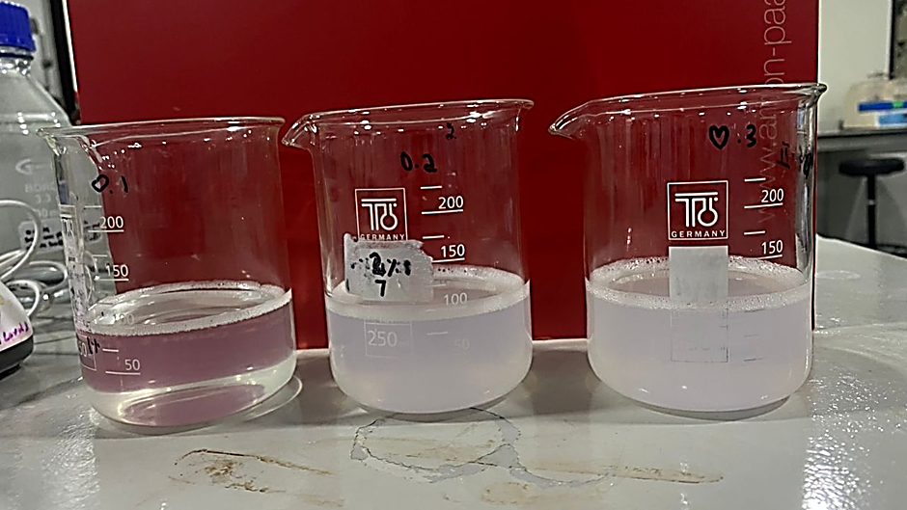

Figure 1: Face mist formulations with different chamomile concentrations. (0.1 %w/w, 0.2% w/w, and 0.3 % w/w)

Particle size and zeta potential of formulations
Table 2. Particle size and zeta potential of formulations
Formulation | Mean particle size (nm) | Zeta potential (mV)
F1 (0.1%) | 737.0 ± 12.3 | −7.5 ± 0.6
F2 (0.2%) | 296.4 ± 10.2 | −6.9 ± 0.4
F3 (0.3%) | 310.0 ± 8.5 | −11.1 ± 0.7
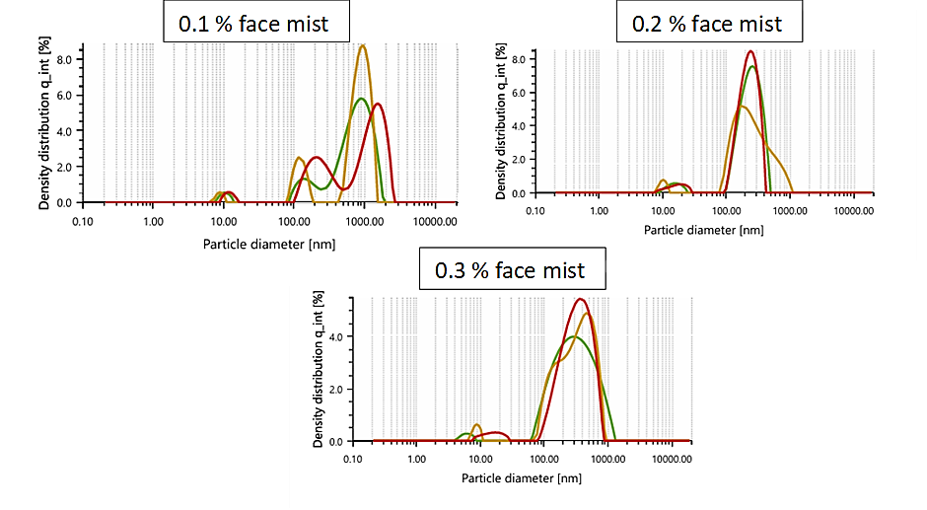
Figure 2: particle size of face mist formulations with different chamomile concentrations (0.1 %w/w, 0.2% w/w, and 0.3 % w/w).

Figure 3: Zeta potential of face mist formulations with different chamomile concentrations (0.1 %w/w, 0.2% w/w, and 0.3 % w/w).

A decrease in mean droplet size was observed with increasing chamomile oil concentration up to 0.2%, with F2 achieving optimal nanoscale formation (<300 nm). This reduction is attributed to efficient surfactant adsorption at the enlarged oil–water interface, lowering interfacial tension. However, a slight size increase at 0.3% oil (F3) suggests over-saturation of the interface beyond the emulsifier’s stabilization capacity. Comparable trends are frequently observed in nanoemulsion systems where excessive internal oil phase alters curvature balance and micellar organization.
All formulations exhibited moderately negative zeta potential values (−6.9 to −11.1 mV), sufficient to maintain kinetic stability through electrostatic and steric hindrance provided by the polyethylene oxide chains of Tween 80. Although −30 mV or greater is generally required for electrostatic stabilization, steric repulsion in non-ionic emulsifiers ensures stability even with low zeta potentials, consistent with reports by Dantas et al. (2016) and Mazzarino et al. (2018).

pH and Viscosity
Table 3. pH and viscosity of formulations
Formulation | pH | Viscosity (mPa·s)
F1 | 4.61 | 18.1
F2 | 5.56 | 17.8
F3 | 5.43 | 17.8
The pH values fell within the physiologically acceptable range for skin, indicating compatibility with the epidermal acid mantle. Maintaining acidity is essential to resist pathogen colonization and preserve barrier integrity. All formulations demonstrated low viscosity (<20 mPa·s), contributing to a fine spray and rapid absorption. The near-water fluidity promotes uniform film formation upon spraying, ensuring rapid dermal hydration without residue or tackiness—an essential parameter for consumer satisfaction in mist-type cosmeceuticals.
Skin Hydration and Elasticity Response
Hydration studies revealed distinct temporal effects among the formulations. F3 (0.3% w/w) produced the highest immediate moisture surge (96%) and elasticity gain (71%), correlated with the presence of chamomile sesquiterpenes (bisabolol, chamazulene) known to enhance stratum corneum pliability and microcirculation. F2 (0.2% w/w) sustained hydration for up to 60 minutes, suggesting a superior balance between aqueous and lipidic phases enabling prolonged moisture retention. Meanwhile, F1 (0.1% w/w) showed moderate long-term oil restoration, beneficial for dry and sebum-deficient skin types.
These findings underline that the synergistic cucumber–chamomile complex modulates both the hydrophilic and lipophilic pathways of skin conditioning, reflecting enhanced humectant function of cucumber polysaccharides and occlusive effects of the essential oil phase.
Spray Characteristics and Drying Behaviour
The spray dispersion diameters varied from 5.5 cm (F2) to 11.6 cm (F1), reflecting minor variations in viscosity and droplet breakup. F2’s smaller yet uniform pattern denotes optimal atomization suitable for controlled application. Drying time analysis exhibited progressive reduction with increasing oil content—likely due to the greater volatility of chamomile oil promoting rapid evaporation. F3 dried within approximately 53 seconds, compared to 139 seconds for distilled water, demonstrating excellent sensory acceptability.
Stability Studies
All samples withstood centrifugation, freeze–thaw cycling, and thermostability stress testing without visible separation, creaming, or turbidity changes, substantiating the thermodynamic stability of the nanoemulsions. Tween 80 effectively maintained interfacial integrity through steric stabilization, while the absence of preservatives did not compromise physical quality, supporting the eco-friendly and preservative-free claims of the formulation.
Antioxidant Activity
Table 4: Free radical scavenging activity of cucumber extract using DPPH.
CONCENTRATION (µg/mL) | PERCENTAGE INHIBITION (%)
0 | 0
400 | 2.03
800 | 36.01
1200 | 55.55
2000 | 79.48

The antioxidant potential of cucumber extract was quantified using the DPPH radical scavenging assay at incremental concentrations (0–2000 µg/mL). The extract exhibited a concentration-dependent increase in free radical inhibition, with percentage inhibition recorded at 0% (0 µg/mL), 2.0% (400 µg/mL), 36.0% (800 µg/mL), 55.6% (1200 µg/mL), and 79.5% (2000 µg/mL). Notably, at the highest tested concentration (2000 µg/mL), inhibition reached nearly 80%, confirming strong free radical scavenging activity in Table 4.
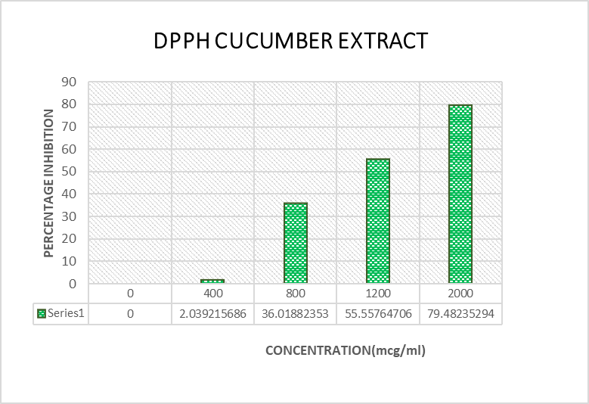

Figure 4: Cucumber extract - DPPH activity

- Discussion
Nanoemulsions offer a promising platform for green cosmeceutical innovation, combining enhanced physicochemical stability and superior skin delivery of botanical actives, even when formulated without synthetic preservatives. The formulations in this study maintained colloidal stability under stress (freeze–thaw, temperature cycling, centrifugation) with no observable phase separation, creaming, or instability—results substantiated by previous nanoemulsion work focusing on essential oil encapsulation and non-ionic surfactant stabilization (30,31). This outcome is largely attributable to Tween 80’s steric stabilization mechanism, which impedes droplet aggregation regardless of relatively modest zeta potential values. Similar studies have highlighted that non-ionic surfactants preserve nanoemulsion integrity in cosmetic and pharmaceutical applications, allowing for clean-label, preservative-free products without sacrificing shelf life.
The optimal particle size achieved (296–310 nm at 0.2–0.3% w/w chamomile oil) correlates with literature reporting improved skin adherence, penetration, and controlled release for nanoemulsions within the submicron size range (14). Skin permeation models and clinical studies demonstrate that droplets below 500 nm are ideal for efficient cutaneous bioactive delivery, due to their increased surface area and enhanced interaction with stratum corneum lipids. The reduction in size with increasing oil content up to 0.2% w/w indicates effective emulsification and surfactant coverage, while the slight size increase at 0.3% w/w suggests approaching the surfactant saturation point, as previously described by Kotta et al. (2012) and Ehrhardt & Kim (2008).
All formulations maintained pH values (4.61–5.56) safely within the physiological range for cutaneous applications, thus supporting the integrity of the epidermal acid mantle. This is vital for barrier function and resistance against pathogenic colonization, and mirrors recommendations from clinical skincare guidelines (2). Viscosity measurements were close to that of water (<20 mPa·s), facilitating the formation of ultrafine mists that ensure rapid dermal hydration and non-tacky, user-friendly finish—qualities critical for consumer adoption of mist-type cosmeceuticals. Studies on nanoemulsion gels confirm that low viscosity enhances both penetration and acceptability in topical use.
The skin hydration and elasticity analysis revealed concentration-dependent effects: the 0.3% w/w chamomile sample induced the highest initial moisture and elasticity, likely due to bisabolol and chamazulene’s well-documented ability to boost collagen synthesis and microcirculation (16,24). Sustained hydration with the 0.2% w/w formula suggests an optimal oil–water ratio supporting prolonged barrier function, also supported by recent research on cucumber polysaccharide humectancy. These functional attributes align with the core goals of green cosmeceuticals: gentle yet effective moisturization and dermal support through botanical synergies.
Spray pattern and drying times further reinforced formulation quality. (33) The larger spray diameters observed for 0.1% w/w and 0.3% w/w samples reflect lower viscosity and surface tension, producing a wider distribution, while the 0.2% w/w sample’s smaller yet uniform spray indicates optimal emulsification performance. Chamomile oil’s volatility accelerated drying, especially at higher concentrations, again supporting user comfort and practicality.
The marked, dose-dependent increase in DPPH inhibition substantiates cucumber extract’s robust antioxidant activity, consistent with its rich composition of phenolic compounds, flavonoids, and vitamins as reported in the literature. These phytochemicals are known to neutralize reactive oxygen species, thus mitigating oxidative stress and offering cytoprotective benefits to skin cells.
At concentrations above 800 µg/mL, the extract’s inhibitory effect escalated sharply, reaching over 79% at 2000 µg/mL. This places cucumber extract among the more potent botanical antioxidants, reinforcing its suitability for applications in preservative-free cosmeceutical nanoemulsions designed to combat skin aging and oxidative damage.
These findings not only justify the incorporation of cucumber extract for its hydrating and soothing properties but also highlight its therapeutic efficacy in skin formulations targeting environmental and endogenous oxidative stress. The pronounced antioxidant profile supports the multifunctional positioning of green nanoemulsion cosmeceuticals, providing both immediate hydration and long-term dermal defences. (34)
Stability assessments (freeze–thaw cycling, centrifugation, thermostability) confirmed physical robustness. Non-ionic, steric stabilization by Tween 80 effectively maintained droplet integrity, echoing reports that highlight its superiority for “green” nanoemulsion dispersions intended for preservative-free cosmetics.

- Conclusion
This preservative-free, eco-friendly cucumber–chamomile nanoemulsion demonstrates that advanced botanical nanoemulsions can achieve pharmaceutical-grade physicochemical stability, superior hydration, and optimal user sensory attributes with minimal ingredient complexity. Mechanistic alignment with the literature reinforces the importance of surfactant selection, particle size control, and bioactive synergy in developing next-generation herbocosmeceuticals. The current physicochemical and sensory results warrant further preclinical and clinical validations to confirm in vivo antioxidant, anti-inflammatory, and antimicrobial efficacy, paving the way for scalable green cosmeceutical innovation.

References:
- Yousef H, Alhajj M, Fakoya AO, Sharma S. Anatomy, Skin (Integument), Epidermis. StatPearls [Internet]. Treasure Island (FL): StatPearls Publishing; 2024 Jun 7 [cited 2025 Oct 10]. Available from: https://www.ncbi.nlm.nih.gov/books/NBK470464/

- Cleveland Clinic. Skin: Layers, Structure and Function; 2025 Mar 18 [cited 2025 Oct 10]. Available from: https://my.clevelandclinic.org/health/body/10978-skin

- Alnuqaydan AM, Alyahya RS, AlHasson MA. The dark side of beauty: an in-depth analysis of adverse cosmetic reactions. Dermatitis. 2024 Aug 25.

- Alyahya RS, AlHasson MA, Alhsaon MA. Assessing the adverse effects and safety concerns related to cosmetic and skincare products: a systematic review. Cureus. 2025 Apr 5;17(4):e81759. doi:10.7759/cureus.81759

- Michalak M, Godlewska K, Pacyga P, Najda A. Plant extracts as skin care and therapeutic agents. Molecules. 2023 Oct 21;28(20):9069. doi:10.3390/molecules28209069

- Future Market Insights. Natural Cosmetics Market Size & Innovations 2025-2035. 2025 Jun 10 [cited 2025 Oct 10]. Available from: https://www.futuremarketinsights.com/reports/natural-cosmetics-market

- Skinician. Cucumber benefits for skin. 2023 Jul 19 [cited 2025 Oct 10]. Available from: https://www.skinician.com/pages/cucumber-for-skin

- NDTV Lifestyle. 9 Benefits of Chamomile Oil for Skin, Hair and Health. 2022 Nov 21 [cited 2025 Oct 10]. Available from: https://www.ndtv.com/lifestyle/9-benefits-of-chamomile-oil-for-skin-hair-and-health-3543896

- CosmeticsDesign. High-tech beauty: exploring nanotechnology’s role in cosmetic formulations. 2024 Aug 25 [cited 2025 Oct 10]. Available from: https://www.cosmeticsdesign.com/Article/2024/08/26/high-tech-beauty-exploring-nanotechnology-s-role-in-cosmetic-formulations/

- IJRPR. A review of herbal cosmetics and their benefits. 2023 [cited 2025 Oct 10]. Available from: https://ijrpr.com/uploads/V6ISSUE3/IJRPR39928.pdf

- Meticulous Research. Natural Cosmetics Market Size & Share Forecast 2032. 2024 Dec 31 [cited 2025 Oct 10]. Available from: https://www.meticulousresearch.com/product/natural-cosmetics-market-6139

- Revivalabs. The Refreshing Essence of Cucumber Extract for Your Skin. 2023 Nov 26 [cited 2025 Oct 10]. Available from: https://www.revivalabs.com/the-refreshing-essence-of-cucumber-extract-for-your-skin/

- Sadhev. Experience the Great Benefits Of Using Chamomile Oil For Skin. 2024 Dec 30 [cited 2025 Oct 10]. Available from: https://sadhev.com/blogs/journal/great-benefits-of-using-chamomile-oil-for-skin

- Gupta V, Verma P, Sai P, et al. Nanotechnology in Cosmetics and Cosmeceuticals—A Review. J Nanomed Nanotechnol. 2022 Mar 9;13(2):1000727. doi:10.35248/2157-7439.22.13.727

- Mananggit KD, Malalay AP. Whitening and hydrating property of cucumber fruit extract (Cucumis sativus) as a lightening serum. Int J Food Med Res. 2025 May-Jun;7(3):93-98. doi:10.36948/ijfmr.2025.v07i03.43714

- Sah A, Naseef PP, Kuruniyan MS, Jain GK, Zakir F, Aggarwal G. A comprehensive study of therapeutic applications of chamomile oil. Evid Based Complement Alternat Med. 2022;2022:1234567. doi:10.1155/2022/1234567

- Foteva T. Nanotechnology in the cosmetic industry (Review). J Chem Technol Metall. 2024;59(1):1-10. doi:10.59957/jctm.v59.i1.2024.1

- Foong FH, Mohammad A, Ichwan SJ. Biological Properties of Cucumber (Cucumis sativus L.) Extracts. Malaysian Journal of Analytical Sciences. 2015.

- Fiume MM, Bergfeld WF, Belsito DV, Hill RA, Klaassen CD, Liebler DC, Marks JG, Shank RC, Slaga TJ, Snyder PW, Andersen FA. Safety Assessment of Cucumis sativus (Cucumber)-Derived Ingredients as Used in Cosmetics. Int J Toxicol. 2014;33(2_suppl):47S-64S.

- Chu YF, Sun J, Wu X, Liu RH. Antioxidant and antiproliferative activities of common vegetables. J Agric Food Chem. 2002;50:6910-6916. doi:10.1021/jf020806l

- Repka V, Fischerova I. Induction and distribution of amylolytic activity in Cucumis sativus L. in response to virus infection. Acta Virol. 1999;43:227-235.

- Pérez-Piñero S, Muñoz-Carrillo JC, Victoria-Montesinos D, García-Muñoz AM, Ávila-Gandía V, López-Román FJ. Effectiveness of a Cucumber Extract Supplement on Articular Pain in Patients with Knee Osteoarthritis: A Randomized Double-Blind Controlled Clinical Trial. Appl Sci. 2022;13(1):485.

- Manion CR, Widder RM. Essentials of essential oils. Am J Health Syst Pharm. 2017;74:e153–e162. doi:10.2146/ajhp151043

- De Cicco P, Ercolano G, Sirignano C, Rubino V, Rigano D, Ianaro A, Formisano C. Chamomile essential oils exert anti-inflammatory effects involving human and murine macrophages: Evidence to support a therapeutic action. J Ethnopharmacol. 2023;311:116391. doi:10.1016/j.jep.2023.116391

- Naseef PP, Kuruniyan MS, Jain GK, Zakir F, Aggarwal G. A comprehensive study of therapeutic applications of chamomile. Pharmaceuticals. 2022;15(10):1284.

- Lisyanti F, Budi S, Zulfadhilah M. Formulation Test of preparations Face Mist combination of pomegranate peel extract and mangosteen peel as an antioxidants. J Adv Med Pharm Sci. 2022;1(1):15–22.

- Rahmadasmi N, Wulandari D, Ah ADH. Review artikel: pemanfaatan bahan alam pada sediaan face mist. J Pharm Sci. 2024:372–378.

- Elchemy. Polysorbate 80 in Cosmetics: Is It Safe for Skincare & Hair Products? 2025 Apr 4.

- Shakeel F, Ramadan W, Shafiq S. Solubility and dissolution improvement of aceclofenac using different nanoemulsion formulations. Colloids Surf B Biointerfaces. 2011;86(1):173–178.

- Dantas MGB, Reis SAGB, Damasceno BPG L, Rolim LA, Rolim-Neto PJ, Carvalho FO, Quintans-Junior LJ, Almeida JRG S. Development and evaluation of stability of a nanoemulsion containing Eucalyptus staigeriana essential oil. Drug Dev Ind Pharm. 2016;42(8):1281–1288.

- Mazzarino L, Borsali R, Lemos-Senna E. Polymeric nanocapsules containing essential oils: Development, characterization, and stability evaluation. Colloids Surf B Biointerfaces. 2018;167:73–84. doi:10.1016/j.colsurfb.2018.03.016

- Kotta S, Khan AW, Pramod K, Ansari SH, Sharma RK, Ali J. Exploring oral nanoemulsions for bioavailability enhancement of poorly water-soluble drugs. Int J Pharm. 2012;431(1–2):161–171.

- Ehrhardt C, Kim KJ. Drug absorption studies: The impact of in vitro and in vivo models. Eur J Pharm Sci. 2008;34(4–5):243–259.

