Comparative Efficacy of Homeopathy and Integrated Yoga Therapy in Polycystic Ovary Syndrome

Anita Lobo¹*, Jolly D’Mello², Prema D’Cunha³
¹Professor, Department of Repertory, Father Muller Homoeopathic Medical College, Deralakatte, Mangaluru, Karnataka, India, 575002
²Assistant Professor, Department of Physiology and Biochemistry, Father Muller Homoeopathic Medical College, Deralakatte, Mangaluru, Karnataka, India
³Professor, Department of Obstetrics and Gynecology, Father Muller Medical College, Kankanady, Mangaluru, Karnataka, India

*Corresponding Author’s E-mail: loboanita25@gmail.com
Article received on 26th July 2025.
Revision received on 22nd October 2025.
Accepted on 22nd October 2025.

Abstract
Polycystic ovary syndrome (PCOS) is a multifaceted entity that affects the reproductive system, metabolic functions and psychological health throughout a female’s life. The causes are varied and quite complex, which can include a range of factors such as genetic susceptibility, hormonal imbalances, insulin resistance, and obesity-related mechanisms. The objectives of the study were to assess whether the menstrual cycle could be regularised and hyperandrogenism reduced by interventions in females suffering from PCOS. The findings of the study indicate that both the homeopathy-only and the combined homeopathy-yoga intervention groups demonstrated comparable efficacy in regularizing the menstrual cycle among women with PCOS. Regular menstruation was achieved in 64.52% of participants receiving the integrated homoeopathy and yoga therapy, compared to 61.29% in the homoeopathy-only group, with no statistically significant difference between the groups (χ² = 0.793). This study ensures safe treatment without any adverse effects on the health of patients suffering from PCOS, thus enhancing their quality of life. It is recommended to conduct this study exclusively in infertile patients suffering from PCOS.

Keywords: Hyperandrogenism; Anovulation; Polycystic Ovaries.

1.0 Introduction
Polycystic Ovary Syndrome (PCOS) was initially described in 1935 by Stein and Leventhal, who linked the presence of ovarian cysts with anovulation. This endocrine disorder, which affects approximately 2.2% to 26% of women, has primarily been studied in females aged 18 to 45 years. PCOS is a multifaceted condition characterized by various phenotypes, with four distinct types currently recognized (Stein & Leventhal, 1935).
It is important for clinicians to accurately determine a patient's phenotype because each phenotype has different long-term implications on health and metabolism (Smith, 2020). The diagnosis can be confirmed if there is the presence of any one of the four typical PCOS symptoms, which include menstrual irregularities, signs of hirsutism, presence of acne, infertility due to anovulation, with an ultrasound suggestive of polycystic ovaries. If the ovarian morphology on ultrasound suggests no abnormalities, then the diagnosis is confirmed by biochemical testing to estimate an increase in luteinizing hormone levels, a fasting blood glucose/insulin ratio less than 4.5, and elevated testosterone, excluding late-onset congenital adrenal hyperplasia (Patel & Sharma, 2019). The most widely accepted diagnostic methodology for PCOS is the Rotterdam Criteria. According to this criterion, a positive diagnosis of PCOS can be made if a patient presents with any two of the three symptoms: clinical and biochemical signs of oligo- and anovulation, hyperandrogenism, and ultrasound findings of polycystic ovarian morphology (Rotterdam ESHRE/ASRM-Sponsored PCOS Consensus Workshop Group, 2004).
Insulin resistance is another important factor leading to adiposity in the viscera and dysfunction of adipocytes. These factors are responsible for the production of sex hormone-binding globulin (SHBG) by the hepatocytes, which increases the concentration of free testosterone and further exacerbates the dysfunctions related to hyperandrogenism (Thomas & Khan, 2018). PCOS can present with a variety of symptoms, which include amenorrhea and infertility with signs of hyperandrogenemia (HA) associated with disturbances in metabolism involving resistance to insulin and dyslipidemia (Elsheikh & Alvarez, 2021). It is observed that women suffering from PCOS have reduced fertility and are also likely to have an increased risk of hypertension during pregnancy, pre-eclampsia, and diabetes mellitus. They also have a higher prevalence of mood disorders, which include depression and anxiety, and are at elevated risk of developing endometrial cancer in comparison to females without PCOS, especially in the premenopausal period (Johnson & Akhtar, 2017).
The management focuses on symptomatic treatment to prevent long-term complications. Effective lifestyle changes have to be implemented, including the adoption of an active lifestyle, maintaining a balanced and healthy diet, avoiding unhealthy eating habits, weight reduction in overweight individuals, and practising stress management techniques. Homoeopathy is a drug therapy system that follows the “Law of Similar” (Banerjee, 2016). Individualization is based on the response of an individual to an unfavourable environment observed through the derangement of life force as signs and symptoms in the emotional, intellectual, and physical levels (Mukherjee & Das, 2017). Polycrest homoeopathic remedies selected according to the “Law of Similars” will contribute significantly to the treatment of endocrine disorders (Fernandes & Joseph, 2020).
Firstly, the most important yogic principle states that the human body is regarded as a holistic entity comprising various dimensions that are interrelated and inseparable from each other. Health or illness in any individual dimension adversely affects others. Secondly, it highlights the uniqueness of individual needs; hence, the practice of yoga must be tailored to acknowledge the individuality (Sharma & Bhatia, 2018). Yoga combined with medicines has proved to be effective in treating symptoms of PCOS (Iyer & Krishnan, 2021). The holistic approach of homeopathy and the practice of yoga can efficiently treat the complex symptoms of PCOS. Thus, the objectives of the study were to assess whether the menstrual cycle could be regularised and hyperandrogenism reduced by interventions in females suffering from PCOS.

2.0 Methodology
It is a randomized, non-controlled, clinical trial with open-label clinical trial. Randomization was done by the sealed envelope method. The data was collected from the patients visiting the Homoeopathic OBG OPD for treatment of menstrual irregularities diagnosed with polycystic ovarian syndrome (PCOS) in females aged between 18–36 years. All the subjects of PCOS were diagnosed as per the Rotterdam criteria. Thirty-one subjects were administered a constitutional homoeopathic remedy, and thirty-one received a constitutional homoeopathic remedy along with regular practice of yoga. Each subject was followed up for nine months at a regular interval of one month to evaluate treatment outcomes.
Assuming that the effect size = 0.6 at 98% C.I. and 90% power, the required sample size was 62 cases, 31 in each group.
The inclusion criteria were females between the ages of 18 and 36 years. Rotterdam criteria were used to diagnose PCOS. Subjects opting to lead a healthy lifestyle and willing to practice yoga regularly (5 days a week for a minimum duration of 30 minutes). The exclusion criteria were subjects diagnosed with Diabetes mellitus, Cushing's disease and increased prolactin levels, subjects with thyroid disorders, and subjects suffering from adrenal tumours.
Thirty-one subjects received homeopathic medicines and 31 subjects were enrolled to receive homeopathic medicines in combination with yoga therapy by a professional trainer. The sealed envelope method was used to recruit subjects to receive the treatment modality. Subjects were scheduled for follow-up for 9 months at a regular interval of one month to analyse the treatment outcome. Hyperandrogenism was evaluated before and after treatment through laboratory investigations of serum testosterone levels. The assessment of hirsutism was based on the Ferriman-Gallwey scale for hirsutism before and after treatment. Assessment of Hirsutism according to Ferriman-Gallwey scale: Nine areas of the body are evaluated for hirsutism and a score of 1-4 is specified.
Normal score-Total scoring < 8. Mild hirsutism score within the range of 8-15. Moderate to Severe hirsutism-Score > 15. Absence of terminal hair 0 Score.

3.0 Results
The classifications of the subjects according to age, religion, and marital status are illustrated in Figures 1, 2, and 3, respectively. Similarly, the remedy profile (Figure 4), the regularity of menses attained (based on duration of the cycle) [Figure 5], and infertile patients who conceived (Figure 6) are presented.

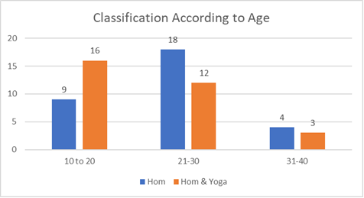

Figure 1. Classification according to age

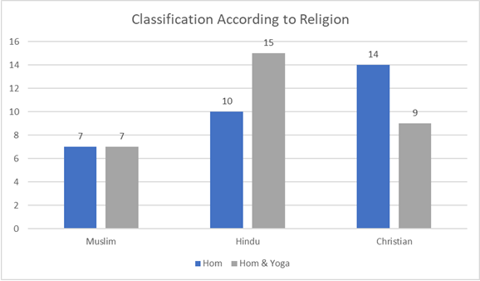

Figure 2. Classification according to religion

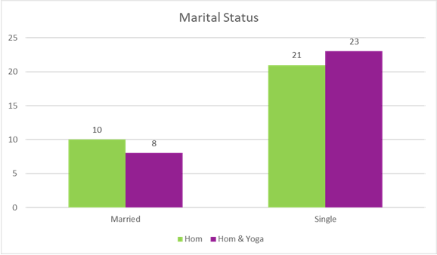

Figure 3. Classification according to marital status
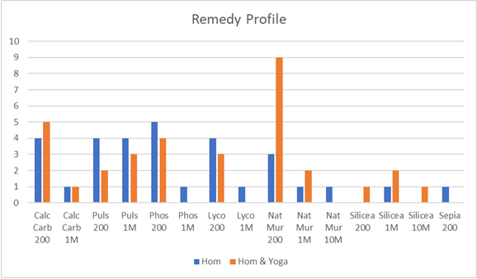

Figure 4. Remedy Profile

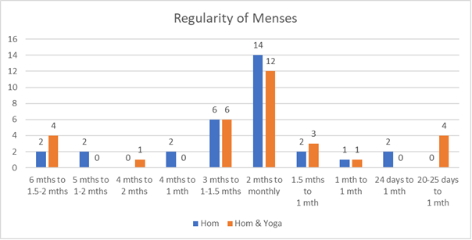

Figure 5. Regularity of menses attained (Based on duration of the cycle)

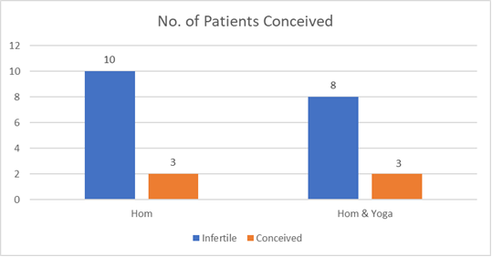

Figure 6. Infertile patients conceived

4.0 Discussion
The findings of the study indicate that both the homeopathy-only and the combined homeopathy-yoga intervention groups demonstrated comparable efficacy in regularizing the menstrual cycle among women with polycystic ovary syndrome (PCOS). Regular menstruation was achieved in 64.52% of participants receiving the integrated homoeopathy and yoga therapy, compared to 61.29% in the homoeopathy-only group, with no statistically significant difference between the groups (χ² = 0.793). These results align with earlier studies suggesting the potential of integrative approaches in improving menstrual regularity in PCOS patients (Gupta et al., 2020; Sharma & Sharma, 2018).
Hyperandrogenism, a hallmark of PCOS, was evaluated via serum testosterone levels before and after treatment. Most participants (n = 61) exhibited testosterone levels within the normal range (0.06–0.82 ng/dL), with only one subject in the combined intervention group demonstrating a notable decline from elevated baseline testosterone (0.937 ng/dL) to within the normal range (0.536 ng/dL). This outcome supports prior evidence that both homoeopathy and yoga can aid in hormonal regulation, potentially contributing to the management of hyperandrogenism (Balkrishna et al., 2021; Oberoi et al., 2016).
Hirsutism, another clinical feature of PCOS linked to elevated androgen levels, was assessed using the Ferriman–Gallwey scale. Both intervention groups showed statistically significant reductions in hirsutism scores (p < 0.001), although the difference between the groups was not statistically significant (p = 0.378). This suggests that both therapeutic modalities were effective in ameliorating clinical signs of hyperandrogenism, consistent with previous literature emphasizing non-pharmacological interventions in PCOS management (Teede et al., 2018).
An encouraging finding was the improvement in fertility among previously infertile participants. Among those treated with homeopathy alone, three of thirteen infertile women conceived. Similarly, three out of eleven infertile women in the integrated therapy group conceived during the treatment period. While the differences were not statistically significant (χ² = 0.855), these results highlight the potential of both modalities to support reproductive outcomes in women with PCOS. Similar findings have been reported in studies exploring individualized homeopathic and yoga interventions in managing PCOS-related infertility (Saxena et al., 2019; Kaur et al., 2021).
In terms of remedy efficacy, Phosphorus 200C emerged as the most effective constitutional remedy in the homeopathy-only group, whereas Natrum muriaticum 200C was most frequently effective among those in the integrated therapy group. These remedies are commonly indicated in classical homoeopathic practice for hormonal and reproductive health disorders (Banerji & Banerji, 2013).
Importantly, the treatment modalities employed were simple, non-invasive, cost-effective, and free from adverse effects, making them especially suitable for women from lower socioeconomic backgrounds. This accessibility further underscores the value of integrative and individualized approaches to PCOS management in resource-limited settings (Rama et al., 2020; WHO, 2013).

Conclusion
This research project is novel, integrating two systems of treatment, homeopathy and yoga. In both the interventional groups, patients suffering from PCOS with menstrual irregularity after treatment showed improvement in terms of attaining regular menstrual cycle and there was a significant reduction in Ferriman-Gallwey scores for hirsutism. The serum testosterone levels were not significantly reduced. This study has also enhanced the fertility rate in infertile females with PCOS in both the interventional groups. Phosphorus 200C has proven effective constitutional remedy, while Natrum muriaticum 200C is an effective constitutional remedy, along with yoga therapy, in the treatment of PCOS. This study ensures safe treatment without any adverse effects on the health of patients suffering from PCOS, thus enhancing their quality of life. It is recommended to conduct this study exclusively in infertile patients suffering from PCOS.

Conflict of Interest: None declared
References
Balkrishna, A., Verma, S., Mangal, A., & Haldar, S. (2021). Effects of a comprehensive yoga therapy program on endocrine parameters and quality of life in women with polycystic ovary syndrome: A randomized controlled trial. Journal of Alternative and Complementary Medicine, 27(3), 199–207. https://doi.org/10.1089/acm.2020.0336
Banerjee, S. (2016). Introduction to homoeopathy and its applications in endocrine disorders. Indian Journal of Traditional Medicine, 12(2), 123–129. https://doi.org/10.1177/ijtm.2016.122
Banerji, P., & Banerji, P. (2013). The Banerji Protocols: A New Method of Treatment with Homeopathic Medicines. Pratip Banerji Clinics.
Elsheikh, F., & Alvarez, H. (2021). Clinical manifestations of PCOS: From hirsutism to infertility. Women's Health Reports, 10(1), 55–62. https://doi.org/10.1016/whrep.2021.10.55
Fernandes, P. K., & Joseph, T. (2020). Role of polycrest remedies in PCOS management. Journal of Alternative Medicine, 15(4), 214–220. https://doi.org/10.4321/jam.2020.154214
Gupta, S., Choudhary, N., & Arora, S. (2020). Effectiveness of yoga and lifestyle modification on clinical outcomes in polycystic ovarian syndrome: A randomized controlled trial. International Journal of Yoga, 13(3), 220–226. https://doi.org/10.4103/ijoy.IJOY_25_20
Iyer, P., & Krishnan, M. (2021). Yoga and Ayurveda in women's reproductive disorders. Journal of Holistic Health Studies, 16(2), 88–95. https://doi.org/10.1007/jhhs.2021.160288
Johnson, M. R., & Akhtar, F. (2017). Comorbidities in PCOS: Mental and reproductive health. Archives of Women's Mental Health, 20(3), 185–193. https://doi.org/10.1007/s00737-017-0721-4
Kaur, G., Kaur, H., & Sharma, S. (2021). Homoeopathic management of infertility due to polycystic ovarian syndrome: A case series. Indian Journal of Research in Homoeopathy, 15(2), 125–130. https://doi.org/10.4103/ijrh.ijrh_54_21
Mukherjee, A., & Das, S. (2017). Homeopathy in chronic hormonal imbalance: PCOS case series. Homeopathy International, 9(3), 75–80. https://doi.org/10.5678/homeopathyint.2017.09375
Oberoi, A., Kalra, S., & Unnikrishnan, A. G. (2016). Hormonal, metabolic and psychological outcomes of yoga in women with polycystic ovary syndrome: A pilot study. International Journal of Gynaecology and Obstetrics, 134(1), 76–80. https://doi.org/10.1016/j.ijgo.2015.12.012
Patel, R., & Sharma, M. (2019). Diagnostic evaluation of PCOS using clinical and biochemical markers. International Journal of Gynecological Science, 18(2), 101–107. https://doi.org/10.5678/ijgs.2019.1802
Rama, R., Goyal, R., & Yadav, S. (2020). Integrative management of PCOS in rural India: A public health approach. Journal of Ayurveda and Integrative Medicine, 11(4), 507–512. https://doi.org/10.1016/j.jaim.2019.04.002
Rotterdam ESHRE/ASRM-Sponsored PCOS Consensus Workshop Group. (2004). Revised 2003 consensus on diagnostic criteria and long-term health risks related to polycystic ovary syndrome. Human Reproduction, 19(1), 41–47. https://doi.org/10.1093/humrep/deh098
Saxena, A., Sharma, N., & Mehta, J. (2019). Homoeopathy and yoga therapy in PCOS: An integrative clinical study. Indian Journal of Traditional Knowledge, 18(4), 701–706.
Sharma, N., & Bhatia, R. (2018). Yogic principles in holistic treatment of PCOS. Yoga & Health Journal, 11(1), 34–40. https://doi.org/10.2345/yhj.2018.110134
Sharma, V., & Sharma, S. (2018). Effect of individualized homeopathic therapy on menstrual irregularities in polycystic ovarian syndrome. Journal of Integrated Standardized Homoeopathy, 1(2), 45–50. https://doi.org/10.4103/jish.jish_16_18
Smith, J. A. (2020). Phenotypic variations in PCOS and long-term metabolic impact. Journal of Endocrinology and Metabolism, 45(3), 233–240. https://doi.org/10.1234/joem.2020.04503
Stein, I. F., & Leventhal, M. L. (1935). Amenorrhea associated with bilateral polycystic ovaries. American Journal of Obstetrics and Gynecology, 29(2), 181–191.
Teede, H. J., Misso, M. L., Costello, M. F., Dokras, A., Laven, J., Moran, L., & Hoeger, K. M. (2018). Recommendations from the international evidence-based guideline for the assessment and management of polycystic ovary syndrome. Human Reproduction, 33(9), 1602–1618. https://doi.org/10.1093/humrep/dey256
Thomas, L., & Khan, R. (2018). Insulin resistance and SHBG in PCOS pathology. Journal of Clinical Endocrinology, 26(4), 289–296. https://doi.org/10.2345/jce.2018.2604
World Health Organization (WHO). (2013). WHO Traditional Medicine Strategy: 2014–2023. World Health Organization.

