Online Advertising and Consumer Perceptions of Herbal Cosmeceuticals: A Cross-Sectional Evaluation of Malaysian E-Commerce Platforms

Vinesen Mohan^{1,} Shafqat Hussain¹, Hiba Mohammed Salih Ali¹, Chen Liang^{1,} Chun Hoe Tan^{1*}

¹Department of Biotechnology, School of Nursing and Applied Sciences, Lincoln University College, 47301 Selangor, Malaysia.

*Corresponding Author’s E-mail: chunhoe@lincoln.edu.my
Other authors: Vinesen Mohan–vinesenmohan@yahoo.com; Shafqat Hussain–shafqatkhoso255@gmail.com; Hiba Mohammed Salih Ali – hiba30171@gmail.com; Chen Liang– liangchenliangliang@gmail.com

Article received on 23rd October 2025.
Revision received on 28th October 2025.
Accepted on 1st November 2025.

Abstract
The global trend toward online shopping has accelerated markedly in recent years, particularly following the COVID-19 lockdown. Consumers now prefer purchasing herbal cosmeceutical products through online platforms rather than in physical stores. This study aimed to examine the advertising practices of herbal cosmeceutical products on selected online platforms and to explore consumer purchasing behavior. A total of 50 products were randomly selected from two anonymized online shopping sites and evaluated based on their ingredient composition, adherence to advertising guidelines, and approval status by the Ministry of Health (MOH). In parallel, a survey involving 125 participants was conducted to gather demographic data and assess consumer knowledge and attitudes toward these products. Results revealed that 72% of the analyzed products were unregistered with the MOH, and many consumers held the misconception that all herbal products are inherently safe. Additionally, the majority of consumers believe that online shopping is convenient, time-saving, and safe.

Keywords: E-commerce; Guidelines; Knowledge; Ministry of Health; Safety.

1.0 Introduction
Online shopping is an important part of contemporary global consumerism and has changed the way people shop and engage with brands. Being able to purchase a wide range of products and services without leaving the house has attracted more consumers to online platforms. Lazada, Shopee, and TikTok Shop are some examples of e-commerce giants that consumers turn to for a variety of products. The increased number of options has fostered competition among retailers; thus, they create innovative strategies to capture and maintain customers’ attention. Personalization is one of the most crucial aspects of the online shopping culture that currently dominates the market (Alimamy & Gnoth, 2022). Moreover, today’s online shopping culture is primarily defined by convenience, customization options, and connectivity. As overall consumer expectations and technology continue to develop, businesses are forced to remain flexible and creative to stay competitive.
Cosmeceutical herbal products bridge the gap between traditional herbal treatments and modern skincare research, offering consumers a natural yet effective skincare solution. These products harness the power of botanical ingredients, including antioxidant-rich green tea, energizing ginseng, and soothing aloe vera, which have been demonstrated to have great effects on the skin. The growing focus on well-being and sustainability in cosmeceutical herbal products attracts consumers searching for gentle yet potent alternatives to conventional skincare formulae (Rashid et al., 2023).
The COVID-19 pandemic has further catalyzed the online shopping trend. Massive lockdowns and social distancing made physical retail an unviable option for most people. E-commerce infrastructure and the integration of omnichannel solutions became a necessity, and businesses had to adjust quickly to the new reality (Young et al., 2022). Online shopping for cosmeceutical herbal treatments offers several advantages beyond convenience. Online retailers often provide detailed product descriptions, ingredient listings, and user reviews, which help customers make educated purchasing decisions. To enhance the value proposition for consumers and promote repeat business, several online platforms now provide loyalty programs, discounts, and promotions. However, navigating the herbal cosmeceutical online business is not without its challenges. Because there are many brands and products on the market, buyers must be able to differentiate between superior knockoffs and genuine products. Concerns about the authenticity of products, the source of ingredients, and environmental sustainability may also lead customers to demand responsibility and openness from companies and online merchants (Tiwari et al., 2020). A previous study conducted by Kutty et al. (2025) reported that trust, perceived risk, and product variety significantly influence online purchasing behaviors in Malaysia during the COVID-19 pandemic. For instance, consumers agreed that they sometimes did not receive what they ordered through the online platform, or the goods received were defective (Kutty et al., 2025). Additionally, perceived consumers’ risks include fear of fraud, concerns about product quality, and fears about the return process (Hipólito et al., 2025). Malaysia does not yet have specific regulations regarding Online Dispute Resolution (ODR) (Najati & Mashdurohatun, 2024).In this regard, there is a need for a comprehensive understanding of online consumer factors and evaluation of the online products' authenticity.
The growing interest in herbal products on e-commerce platforms has sparked curiosity about their definition and the reasons for their popularity. In addition, the implementation of relevant regulations on the advertisement of cosmeceutical herbal products has yet to be investigated. Therefore, this study aims to investigate the cosmeceutical herbal product advertisements in selected online shopping platforms and consumers’ purchase behavior. The research evaluates the type of information in online advertisements promoting cosmeceutical herbal products and determines consumers’ attitudes towards purchasing these products. A total of 50 products were randomly selected from two anonymized online shopping sites and evaluated based on their ingredient composition, adherence to advertising guidelines, and approval status by the Ministry of Health (MOH). The selected two online shopping platforms for evaluation represent the two largest mobile-focused marketplaces in Malaysia, enabling users to browse, shop, and sell products. Unlike other social media or websites, the selected online shopping platforms integrated logistical and payment support to facilitate transactions, and they are designed to operate with minimal physical assets. In parallel, a survey involving 125 participants was conducted to gather demographic data and assess consumer knowledge and attitudes toward these products. The overall research flow chart is shown in Fig. 1.
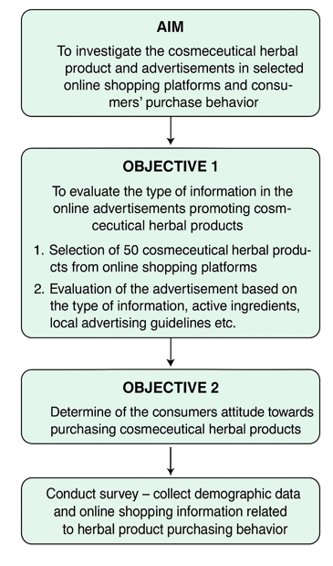
Fig. 1: Research flowchart

2.0 Methodology
2.1. Examination of the Advertising Practices of Herbal Cosmeceutical Products on Selected Online Platforms
2.1.1. Research Design
A cross-sectional, quantitative, and descriptive research design was applied.

2.1.2. Data Collection
A total of fifty (50) cosmeceutical herbal products were randomly selected from two online shopping platforms, using the search terms such as “herbal cosmeceutical”, “natural cosmeceutical”, etc. Cosmetic products and supplements were excluded from this study. The following information was extracted from each product listing: active herbal ingredients, drug form, Ministry of Health (MOH) approval status, product form, quantity sold on the specific platform, route of exposure, dosage, mechanisms of action, and compliance with local advertising guidelines. For the medicinal properties of the herbal ingredients, relevant literature was retrieved from Google Scholar, ResearchGate, and Google search databases. Additionally, the presence or absence of approval numbers, substantiated claims, and guarantees of safety were also assessed. For ethical considerations, the names of the products and online platforms were kept confidential.

2.1.3. Data Analysis
The collected data were analyzed using SPSS version 23.0 (IBM Corp., Armonk, NY, USA) and depicted using Google Forms and Microsoft Excel.

2.2. Assessment of consumer purchasing perception and behavior.
2.2.1. Research Design
A cross-sectional, survey-based quantitative study was employed.

2.2.2. Research Setting
The survey was distributed using Google Forms (https://forms.gle/BvHGXJ861j8SMmoK7/) for over two weeks in the whole nation.

2.2.3. Research Instruments
The self-administered questionnaire was retrieved from various literature sources (Dani, 2017; Tiwari et al., 2020; Bhadauriya et al., 2021) with some modifications. The questionnaire primarily consisted of multiple-choice, closed-ended, checklist, and linear scale questions (1 = Strongly Disagree, 2 = Disagree, 3 = Neutral, 4 = Agree, 5 = Strongly Agree). It was structured into two sections: the first covered demographic information (gender, age, education, employment status, etc.), while the second comprised six domains related to consumer behavior, i.e., convenience, website design/features, time-saving, security, consumer opinion, and consumer preference. The questionnaire is available in the Supplementary Materials. To maintain anonymity and encourage participation, personal identifiers such as name and contact information were excluded. A consent statement was provided at the beginning of the questionnaire, outlining the study purpose, estimated completion time, confidentiality assurances, and voluntary nature of participation. Respondents indicated consent by proceeding to complete the questionnaire.

2.2.4. Research Population and Sampling Technique
The target population consisted of Malaysian adults with prior experience purchasing cosmeceutical herbal products online. A total of 125 respondents were recruited using a snowball sampling technique, with invitations distributed via social media platforms and messaging applications. We used the snowball sampling method as it is cost- and time-effective, and it can be easier to get participants to refer others who are more likely to be similar to them and are more willing to participate. The inclusion criteria were men and women aged 21 years and above who had purchased cosmeceutical herbal products online. Individuals involved in selling these products were excluded from participation.

2.2.5. Data Analysis
Survey responses were analyzed and depicted using SPSS version 23.0. Descriptive statistics were performed to summarize respondent demographics and consumer attitude trends.

3.0 Results and Discussion
3.1. Examination of the Advertising Practices of Herbal Cosmeceutical Products on Selected Online Platforms
3.1.1. Active Ingredients
A total of 50 cosmeceutical herbal products were retrieved from two major online shopping platforms, and the results were displayed in Fig. 2A. The most common active ingredients among the analyzed cosmeceutical herbal products are aloe vera (9%), followed by turmeric (Curcuma longa) (8%) and coconut oil (Cocos nucifera). “Other” (68%) consists of many different ingredients, with only 1–2% abundance for each ingredient. Aloe vera is one species of succulent plant in the genus Aloe (Soetrisno et al., 2020). When applied topically to the skin, bradykinase helps to minimize excessive inflammation, and other enzymes aid in the breakdown of fats and sugars. Aloe vera's humectants retain moisture in the skin by encouraging the formation of collagen and elastin fibers, which might result in fewer wrinkles and fine lines. According to the research, topical application of aloe vera extract decreased caspase-3 expression and the number of sunburn cells in UVB light-exposed skin (Saleem et al., 2022). Turmeric is a flowering plant belonging to the Zingiberaceae family of gingers. It has been widely reported to exhibit anti-inflammatory and antioxidant properties (Dehzad et al., 2023), which could provide skin radiance and gloss. Coconut oil, scientifically known as (Cocos nucifera), is an edible oil derived by mechanical or thermal extraction of a developed kernel from the coconut (Umate et al., 2022). As coconut oil penetrates deeply into hair follicles, it promotes hair growth and strengthens the scalp's defenses against dandruff, lice, and bug bites. From this review, it can be concluded that virgin coconut oil is beneficial for various dermatological disorders. It is antifungal and antibacterial and also acts as an immunomodulator with anti-inflammatory, angiogenic, wound-healing, and skin-protective properties. Another notable active ingredient identified from the search is pomegranate, scientifically known as Punica granatum. The active ingredients of pomegranate are good at preventing premature skin aging. They fight free radicals, encourage cell renewal, and activate the skin's inherent healing mechanisms (Chakkalakal et al., 2022). Oral supplementation with 250 mg of pomegranate fruit extract standardized to 75 mg of punicalagin daily greatly enhanced several skin health markers, with decreases in the appearance of average facial wrinkle severity (Chakkalakal et al., 2022).
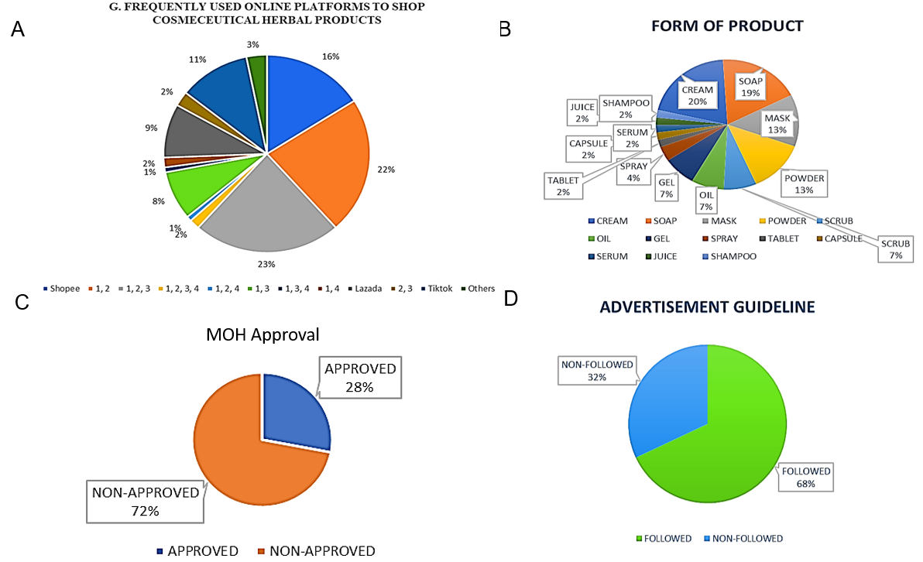
Fig. 2: (A) Active ingredients, (B) form of the product, (C) MOH approval, and (D) advertisement guideline

3.1.2. Form of Product
About 96% of the products surveyed were marketed for external application and packaged mainly as cream (20%), followed by soap (19%), mask (13%), and powder (13%). Emulsions are commonly used in topical dermatological formulations, cosmeceutics, and daily skin care products (Palefsky, 2022). Soap is typically packaged as a solid bar or liquid dispenser and contains surfactants that moisten dirt. Masks are another leading form used to rejuvenate skin, including sheet, peel-off, rinse-off, and hydrogel types (Nilforoushzadeh et al., 2018). Powder refers to a powdered or aqueous solution in which water serves as the solvent, and herbal extracts can be applied directly to the skin in water-based forms (Chaiyana et al., 2021). Other recorded forms were scrub (7%), oil (7%), gel (7%), spray (4%), serum (2%), juice (2%), and shampoo (2%), while a few internal use products (4%) were packaged as tablets (2%) and capsule (2%). The results are displayed in Fig. 2B. Most of the products retrieved are for either topical (92%) or oral (8%) application.

3.3. Ministry of Health (MOH) Approval
As shown in Fig. 2C, 72% of the products were not registered under MOH or known as Kementerian Kesihatan Malaysia (KKM). Some of these unregistered cosmeceutical drugs advertised unverified medicinal claims, such as overnight whitening effects.

3.4. Advertisement Guideline
Within the field of medical marketing, medical advertising is a subgroup that concentrates on using advertisements to market healthcare products and services to prospective patients, and it can appear in a variety of media, such as print and online. Based on the results retrieved from the survey conducted, only 68% of the cosmeceutical herbal product sellers in the online shopping platform followed the advertisement guideline, as shown in Fig. 2D. For example, some sellers advertised non-reasonably rapid fairness results to hype product popularity and increase profits.

3.2. Assessment of Consumer Purchasing Perception and Behavior
3.2.1. Demographic Data
3.2.1.1. Gender
Fig. 3A shows the results of the gender of participants recorded from the survey, where a total of 61.6% of responders were female, indicating that female consumers are more frequent buyers of cosmeceutical herbal products through online shopping platforms compared to males.

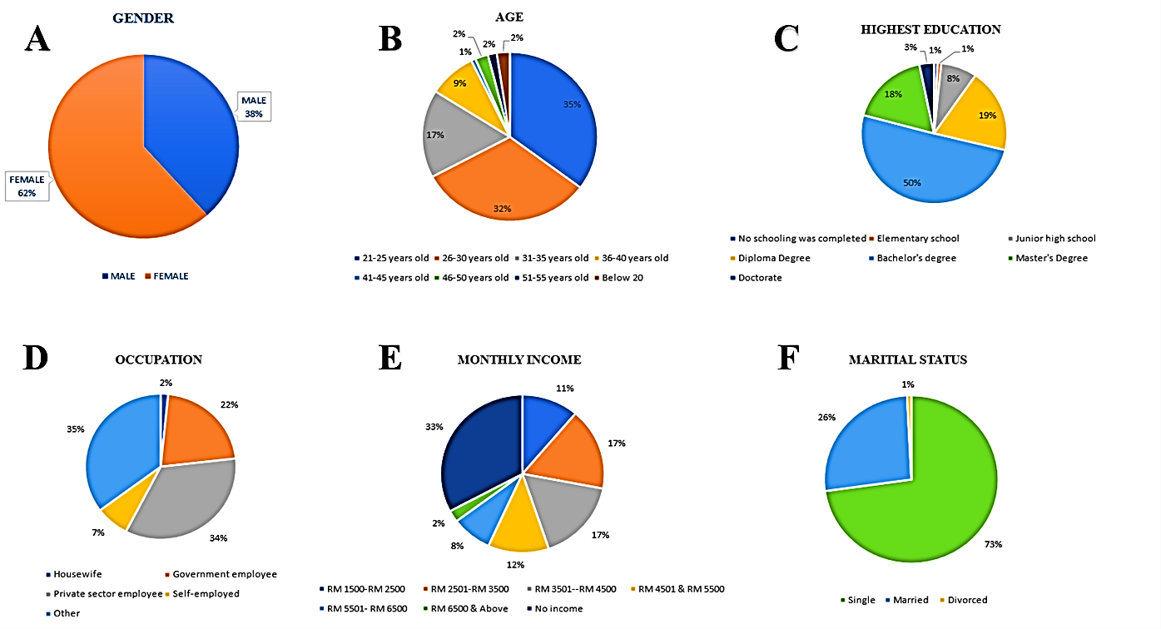Fig. 3: (A) Gender, (B) age, (C) highest education, (D) occupation, (E) monthly income, (F) marital status.

3.2.1.2. Age
Fig. 3B shows the age range of the responders that prefers online shopping, and the majority of respondents who use online shopping to meet their needs are between the ages of 21 to 25, accounting for 35.2% of total consumers, while respondents from the age group of 26 to 30 are the second most possibly to use online purchasing services, accounting for 32%.

3.2.1.3. Highest Education
Fig. 3C shows the percentage distribution of respondents based on educational attainment, Among the 125 selected respondents, 63 of them hold a Bachelor's Degree (50.4%), meanwhile 24 of the respondents have a Diploma Degree (19.2%), 22 of them have a Master's degree (17.6%), followed by junior high school (8%), elementary school (0.8%), and Doctorate (3.2%).

3.2.1.4 Occupation
Fig. 3D shows the percentage distribution of respondents’ occupation categories. Out of 125 respondents, 43 employees (34.4%) are in the private sector, followed by 27 who are government employees (21.6%), 9 of them are self-employed (7.2%), and 2 of them are housewives (1.6%). No participant claimed to be retired.

3.2.1.5 Monthly Income
Fig. 3E shows the record of respondents according to income source. Out of 125 respondents, 41 of them (32.8%) have no income, followed by 21 of them (16.8%) in the category of monthly income between RM 2501–RM3500 and RM 3501–4500 each. Followed by 15 of them (12%) are from RM 4501–RM 5500, 14 of them (11.2%) are RM 1500–RM 2500, 10 of them (8%) are RM 5501–RM 6500, and 3 of them (2.4%) are RM 6500 & above.

3.2.1.6 Marital Status
Fig. 3F shows the marital status percentage of respondents based on the record of the survey conducted. Among the 125 respondents, 91 of them (72.8%) were single, followed by 33 of them (26.4%) were married, and 1 of them (0.8%) was divorced.

3.2.2. Convenience
Fig. 4 shows the result achieved in each element according to the percentage findings indicating that the convenience was agreed across, and 86 of the respondents (68.8%) agreed that they receive the delivery of cosmeceutical herbal products by shopping online perfectly on time and they can able to shop anytime they want to, while 83 (66.4%) of respondents also agreed to the statement that the information about a particular cosmeceutical herbal product is detailed in the particular online shopping platform, and 82 (65.6%) of the respondents feel easy and convenient to choose the cosmeceutical herbal product in the online shopping platform, and 79 (63.2%) of them feel easy to make comparisons with other herbal products while shopping through online shopping platform before making their choice, and this may be due to the convenience provided by the particular online shopping platform and also the detailed information that has been provided by the seller.

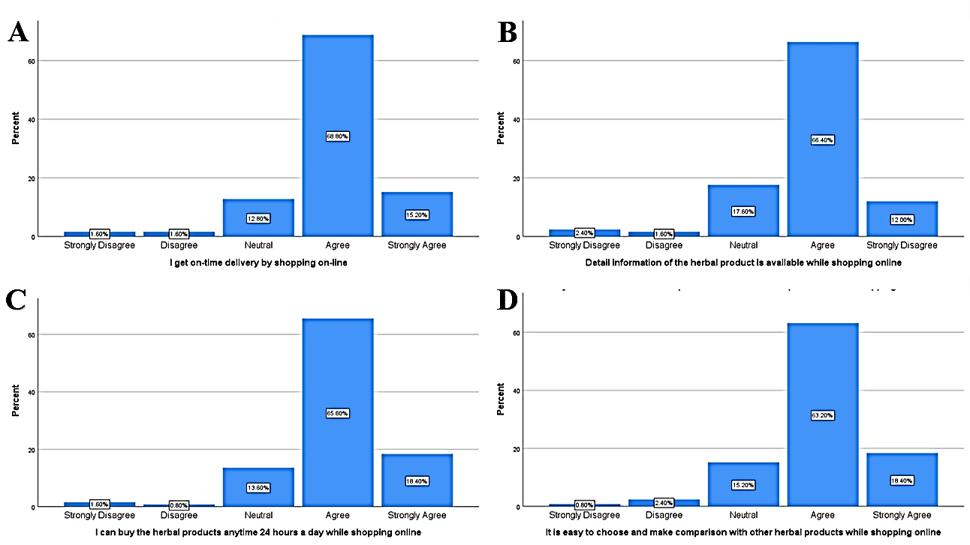
Fig. 4: Convenience

3.2.3. Website design/ Features
Fig. 5 shows the participants’ opinion about the website design and features, and 87 of them (69.6%) feel that the website design and layout help them search the cosmeceutical herbal products easily and select the right product in the particular online shopping platform, while 83 (66.4%) agree that purchasing the product from the platform provides safety, quality of information, and ease of navigation and order.

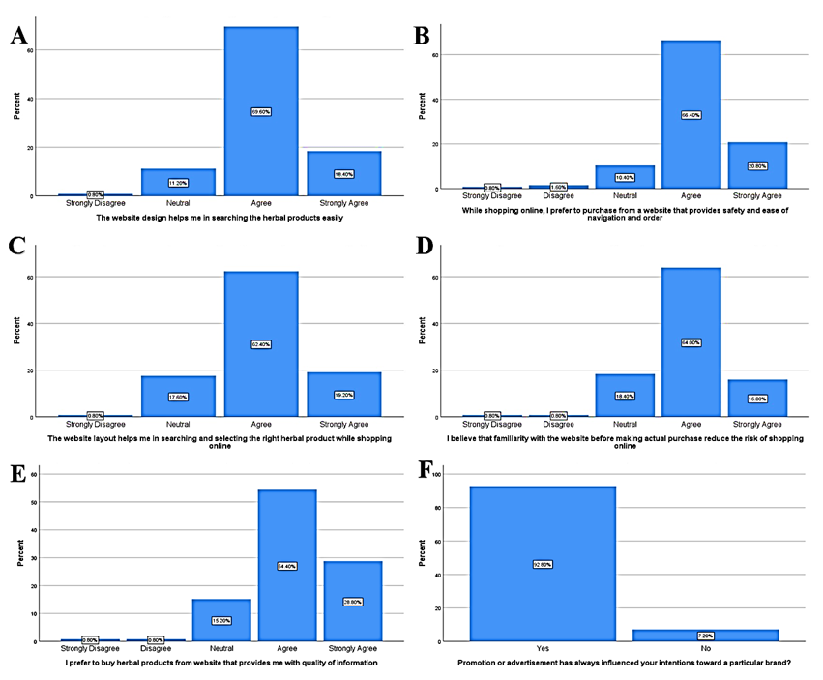
Fig. 5. Website Design/ Features

3.2.4. Time-Saving
About 76 (60.8%) of the respondents agreed that online shopping is time-saving.

3.2.5. Security
Fig. 6 demonstrates that 116 (92.8%) participants did not encounter any observable side effects from the usage of herbal products that have been purchased through the particular online shopping platform. In addition, 69 (55.2%) of the respondents who are consumers felt safe and secure, since the majority of them, which is 72 (57.6%), believe that the particular online shopping platform protects their security while shopping online and 82 (65.6%) of them are aware of the scams.
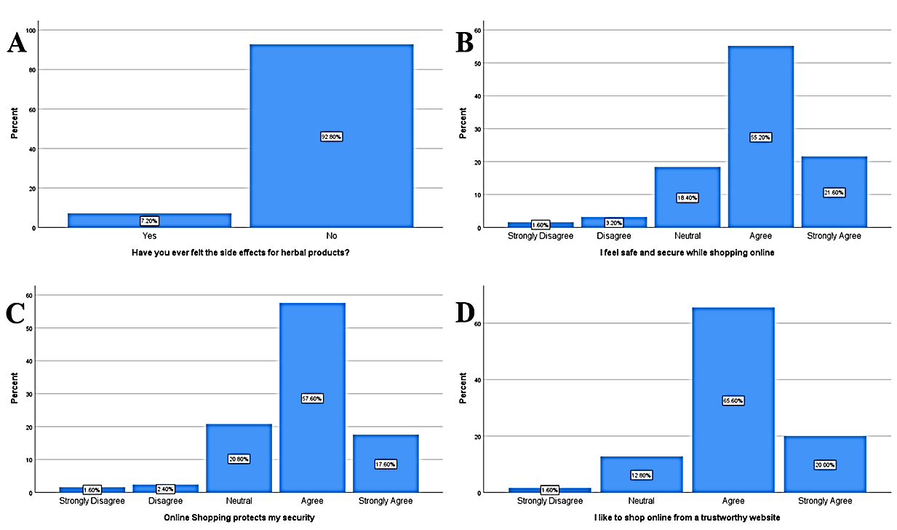
Fig. 6. Security

3.2.6. Consumers’ Preference
Fig. 7 indicates the consumers’ preferences recorded from the survey, and 48 of them had used herbal products for less than one month. About 74 (59.2%) of them were influenced by brand name, 73 (58.4%) by product quality, and 71 (56.8%) by price (Rezai et al., 2013). Our results are in line with those reported by Alicia and Kerti (2024) from Indonesia, in which the consumers’ purchase preference is substantially influenced by the brand image of the herbal products. Consumers trust popular brands due to their safety and positive testimonies. In addition, 69 (55.2%) were influenced by active ingredients, preferring herbal over synthetic products (Dongare et al., 2021). Similarly, Rungsawanpho (2025) reported that the majority of the elderly in Bangkok purchase herbal health products because they are natural and assume that they are safe. Moreover, 68 (54.4%) were influenced by shelf life, and 71 (56.8%) by mechanism and effectiveness, as herbal ingredients such as aloe vera stimulate collagen and hyaluronic acid, cinnamomum contains phenolic antioxidants, coconut oil acts as a moisturizer, and olive oil enhances fatty acid penetration (Gediya et al., 2011). Furthermore, 64 (51.2%) were influenced by the route of exposure, preferring easy-to-use and portable products. Lastly, 30 (24.0%) stated that herbal products do not provoke allergies or irritation, 24 (19.2%) felt they are better in quality and safe, and 22 (17.6%) agreed that their components are not aggressive on the skin.
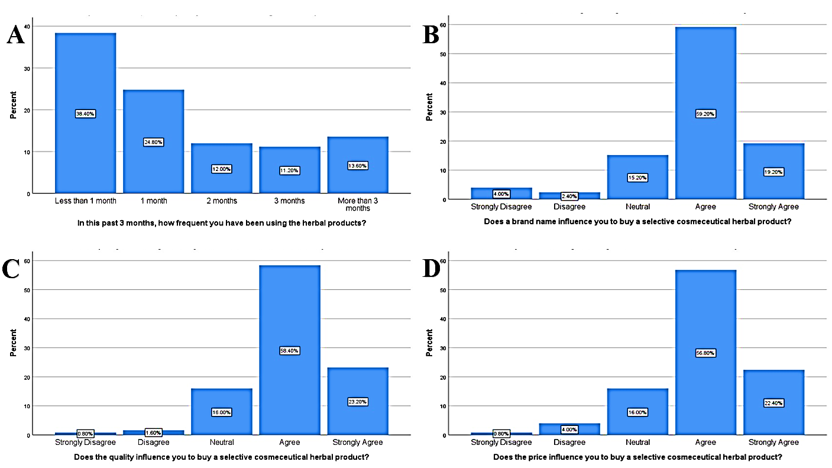
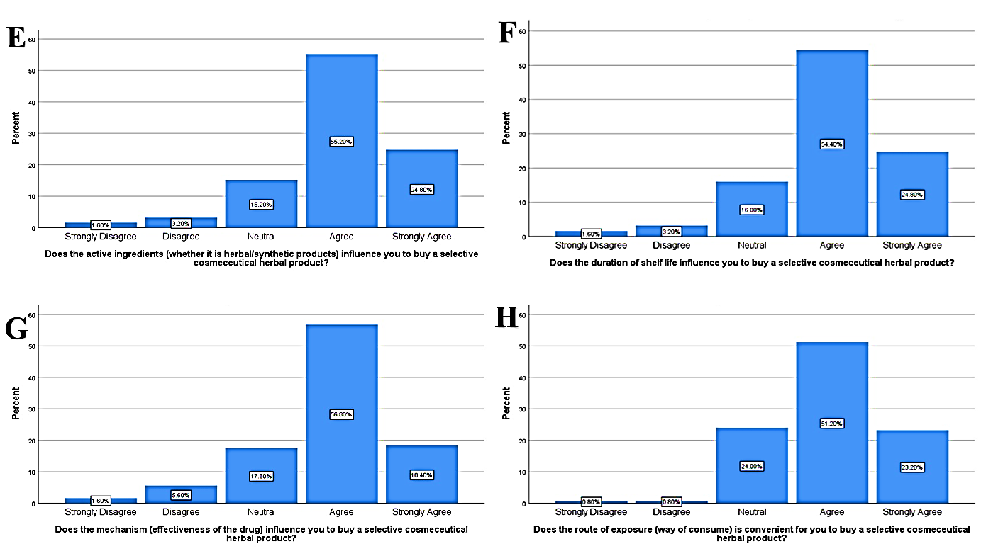
Fig. 7: Consumer’s preference
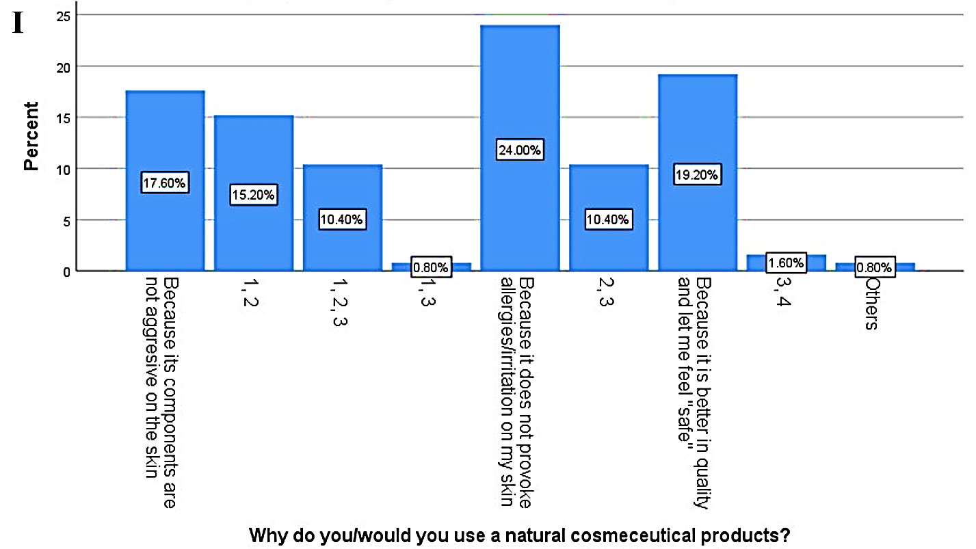

Fig. 7: Consumer’s preference (cont.)

4.0 Theoretical Frameworks
Since our study examines consumer behavior and health-related decision-making, both of which align well with the Theory of Planned Behavior (TPB) and the Health Belief Model (HBM).TPB is a sociological and psychological concept that suggests three elements (attitude towards behavior, subjective norm, perception of behavioral control) are the primary determinants that explain a person's intentions and subsequent conduct in customer behavior (Ajzen, 1991). In our study, consumers prefer online purchases and often overlook product registration or safety; this reflects how attitudes and perceived convenience override cautious evaluation, consistent with the TPB framework. Simultaneously, the findings resonate with the HBM. The Health Belief Model (Rosenstock, 1974) suggests that health-related behaviors are influenced by perceived susceptibility, perceived severity, perceived benefits, perceived barriers, and cues to action. The consumers exhibit low perceived risk and high perceived benefits toward online herbal product purchases, emphasizing the need for targeted health education to reshape risk perceptions and promote safer consumer choices.

Conclusion
Based on the survey results, most of the herbal-based products contain aloe vera, turmeric, and coconut oil. Age, income, and employment status are found to have important variations in the consumption of herbal-based products. It indicates a person's intake of herbal goods is influenced by their status, such as age, marital status, or financial level, and also the product’s price, active ingredient, brand, as well as mechanisms. Along with older age, young adults are also experiencing an increase in purchase and usage rates of cosmeceutical herbal products. This study provided insight into Malaysian consumers' purchasing habits concerning products made from herbal. Pre- and post-test designs should be used in these studies to evaluate the efficacy of different consumer awareness-raising activities, such as creating and distributing educational resources like YouTube videos, booklets, and interactive seminars are some of the suggested approaches. Another limitation is that the use of snowball sampling could be potentially biased, when the sample is not randomly selected and may not be representative of the overall population, as it relies on the initial participants and their social networks, which can lead to a homogenous sample. In the future study, random sampling could be adopted to generalize the findings to a larger population.

Ethical Approval and Consent to Participate
The participants were not coerced into taking part in the survey. The study’s requirements and risks were fully disclosed to the participants, who were also made aware of their right to withdraw from participation at any time. Before the evaluation, the participants verbally consented, and they were informed that their data would be shared for academic purposes. The names of the herbal cosmeceutical products and online platforms were kept confidential.

Availability of Supporting Data
The data that support the findings of this study are not openly available due to reasons of sensitivity and are available from the corresponding author upon reasonable request.

Competing Interests
The authors have no competing interests to declare that are relevant to the content of this article.

Funding
No funding was received for conducting this study.

Authors' Contributions
Vinesen Mohan: Conceptualization, Investigation, Writing – original draft. Shafqat Hussain Investigation, Validation, Writing – review & editing. Hiba Mohammed Salih Ali: Investigation, Validation, Writing – review & editing. Chen Liang: Investigation, Validation, Writing – review & editing. Chun Hoe Tan: Supervision, Validation, Writing – review & editing.

Acknowledgments
This research did not receive any specific grant from funding agencies in the public, commercial, or not-for-profit sectors.

References
Ajzen, I. (1991). The theory of planned behavior. Organizational Behavior and Human Decision Processes, 50(2), 179-211.
Alicia, L. M., & Kerti, Y. N. N. (2024). The role of brand image and perceived quality of products mediate ewom's effect on the purchase intention of millennial consumer: Sido muncul herbal medicine and herbal pharmacy’indonesian consumers study. Statistics, 25(57), 07.
Alimamy, S., & Gnoth, J. (2022). I want it my way! The effect of perceptions of personalization through augmented reality and online shopping on customer intentions to co-create value. Computers in Human Behavior, 128, 107105.
Bhadauriya, P., Jadon, A., & Upadhyay, C. (2021). Study on use, attitude and knowledge of herbal cosmetic products among consumers: Health management. Journal of Applied Pharmaceutical Sciences and Research, 4(2), 1-3.
Chaiyana, W., Charoensup, W., Sriyab, S., Punyoyai, C., & Neimkhum, W. (2021). Herbal extracts as potential antioxidant, anti‐aging, anti‐inflammatory, and whitening cosmeceutical ingredients. Chemistry & biodiversity, 18(7), e2100245.
Chakkalakal, M., Nadora, D., Gahoonia, N., Dumont, A., Burney, W., Pan, A., Chambers, C. J., & Sivamani, R. K. (2022). Prospective randomized double-blind placebo-controlled study of oral pomegranate extract on skin wrinkles, biophysical features, and the gut-skin axis. Journal of Clinical Medicine, 11(22), 6724.
Dani, N. J. (2017). A study on consumers’ attitude towards online shopping. International Journal of Research in Management & Business Studies, 4(3), 42-46.
Dehzad, M. J., Ghalandari, H., Nouri, M., & Askarpour, M. (2023). Antioxidant and anti-inflammatory effects of curcumin/turmeric supplementation in adults: A GRADE-assessed systematic review and dose–response meta-analysis of randomized controlled trials. Cytokine, 164, 156144.
Dongare, P. N., Bakal, R. L., Ajmire, P. V., Patinge, P. A., More, M. P., & Manwar, J. V. (2021). An overview on herbal cosmetics and cosmeceuticals. Int J Pharm Sci Rev Res, 68(1), 75-78.
Gediya, S. K., Mistry, R. B., Patel, U. K., Blessy, M., & Jain, H. N. (2011). Herbal plants: used as a cosmetics. J Nat Prod Plant Resour, 1(1), 24-32.
Hipólito, F., Dias, Á., & Pereira, L. (2025). Influence of Consumer Trust, Return Policy, and Risk Perception on Satisfaction with the Online Shopping Experience. Systems, 13(3), 158.
Kutty, R. B. K. M., Vasudevan, H., & Aslan, I. (2025). Factors Influencing Customers' Online Shopping Behavior in Malaysia During the COVID-19 Pandemic. Journal of Comprehensive Business Administration Research, 2(2).
Najati, F. A., & Mashdurohatun, A. (2024). The Comparative Analysis of Consumer Protection Regulations in E-Commerce Transactions in Indonesia, Singapore and Malaysia. Law Development Journal, 6(2), 200-213.
Nilforoushzadeh, M. A., Amirkhani, M. A., Zarrintaj, P., Salehi Moghaddam, A., Mehrabi, T., Alavi, S., & Mollapour Sisakht, M. (2018). Skin care and rejuvenation by cosmeceutical facial mask. Journal of cosmetic dermatology, 17(5), 693-702.
Palefsky, I. (2022). Creams and Ointments. Cosmetic Dermatology: Products and Procedures, 101-105.
Rashid, J., Sabar, M., Gill, Z., Mustafa, U., Fatima, S., & Ashiq, S. (2023). Cosmeceuticals: The bioactive elements in new-age beauty products. Int. J. Pharm. Integr. Health Sci, 4, 70-82.
Rezai, G., Zahran, M. Z. M., Mohamed, Z., & Sharifuddin, J. (2013). Factors influencing Malaysian consumers online purchase of herbal products. Pertanika Jounal Social Science & Human, 21, 109-122.
Rosenstock, I. M. (1974). The Health Belief Model and Preventive Health Behavior. Health Education Monographs, 2(4), 354-386.
Rungsawanpho, D. (2025). Consumer behavior in herbal health product purchasing among the elderly in Bangkok. Paper presented at the Proceedings National & International Conference.
Saleem, A., Naureen, I., Naeem, M., Murad, H.S., Maqsood, S., & Tasleem, G. (2022). Aloe vera gel effect on skin and pharmacological properties. Scholars international journal of anatomy and physiology, 5(1), 1-8.
Soetrisno, K., Subchan, P., & Hussana, A. (2020). The Administration of Topical Aloe vera Extract Reduce the Number of Sunburn Cells and Expression of Caspase-3 on Post UVB-light-exposure Epidermis. Sains Medika Journal of Medical & Health, 11(2).
Tiwari, M., Dubey, V., & Lahiri, A. (2020). Comparative study of various herbal cosmetics: A survey. Asian Journal of Pharmaceutical and Clinical Research, 13(10), 31-34.
Umate, N., Kuchewar, V., & Parwe, S. (2022). A narrative review on use of virgin coconut oil in dermatology. Journal of Indian System of Medicine, 10(2), 86-89.
Young, M., Soza‐Parra, J., & Circella, G. (2022). The increase in online shopping during COVID‐19: Who is responsible, will it last, and what does it mean for cities? Regional Science Policy & Practice, 14, 162-178.

